PROCEEDINGS OF THE BOARD OF THE COMMISSIONERS

MEAGHER COUNTY, MONTANA

Tuesday

September 5th, 2023

8:30 a.m. – 12:30 p.m.

Met in Commissioner’s Chambers

**Meeting Called to Order:**

Chair Brewer called the meeting to order at 8:30 a.m.

**Commissioners Present:**

Chair Brewer, and Vice Chair Hurwitz and Commissioner Galt were present.

**Claims Review / Minutes Review:**

**ACTION #1**

Commissioner Galt moved to approve the Minutes from August 22nd and August 30th, 2023. Commissioner Brewer seconded the motion. A vote was taken and minutes were approved.

**Monthly Road/Fire Report – Jake Kusek:**

Jake Kusek entered the chambers at 9:00 a.m.

Kusek & the Commission discussed the beaver activity on 16 Mile Creek and Lost Creek and the potential damage to the county road if it persists.

Hurwitz inquired about the new graders and a claim that they may not have as much horse power as the old graders. Kusek stated the new graders have 255 hp compared to the old graders with 185-205 hp, the blades on the new graders stay on the ground better than the old graders. The left front wheel seal started leaking on both the new graders, however the leak has stopped and no repairs are needed at this time. Other machines built in the same time frame had similar problems with the wheel seals. Kusek reported the mower is on the 140M grader and will remain there, the new John Deere graders do not have the correct adaptor for the mower.

The counter on Smith River Rd is still counting approximately 250 vehicles per day and will be left there until after hunting season.

Kusek received the Reclamation Release for the Bodell Gravel Pit from the State of Montana, Department of Environmental Quality (DEQ) and he is continuing to work on getting the Fort Logan Pit permitted. Eric Erben, from Highland Environmental Inc staked out the pit last month and anticipates the permit will be approved and ready for use next summer.

Bryan Holtz and David Collins are attending the 2023 Annual Equipment Operator Training and Snow Rodeo in Missoula. The training consists of one day of classroom training and one day of hands on competition.

Kusek continued with the fire report. The fire truck stationed at Springdale Colony is not running and will need to be replaced. Kusek found a 2011 Ford Fire truck from the State of California, Department of Natural Resources and Conservation. There is no cost for the vehicle, the only cost will be the freight charge of $2500 to have the truck transported to Montana.

The current fire restriction will remain in effect until further notice.

Commissioner Galt requested Kusek reach out to Riverside Contractors, they are bidding the highway project near Martinsdale, to inquire about the milling that will be taken off the highway and could be used to repair the streets in Martinsdale.

**ACTION #2**

**Resolution FY 23.24 #26**

Commissioners approved adding concrete under the doors of the Ringling Fire building to help seal up the building from the weather and rodents.

**Monthly Sheriff Report – Jon Lopp:**

Sheriff Jon Lopp entered the chambers at 10:10 a.m.

Lopp was delayed by a service call, when he arrived he handed out the August 2023 Complaint report for review. Over the Labor Day weekend only 1 speeding ticket was issued. Lopp stated the weather was a factor in the quiet weekend.

Lopp is preparing for an Abandoned Vehicle Sale in October. Currently the county has 22 vehicles and other items to be auctioned off. The minimum bid on each vehicle will be the tow fee for each vehicle. The State of Montana has a Junk Vehicle Program however the county does not have enough abandoned vehicles to utilize the program.

Commissioner inquired about Smith Creek Cabin Sites and how emergency services are handled in that area. Lopp stated Meagher County has a Mutual Aid Agreement with Park County for the Smith Creek area.

**Clerk & Recorder /Superintendent of Schools – Liv West:**

Clerk & Recorder Liv West entered the chambers 10:00 a.m.

West opened by giving an overview of the County Superintendent of Schools duties and the oversight of the home-schooled students. Currently Meagher County has approximately 45 home-schooled students. Springdale Colony and School District 8 have an Attendance Center Agreement to provide education and the Colony Students are part of the “Average Number Belonging” (ANB) for the district. Makayla Bingham has been hired to teach at the Colony.

West presented a spreadsheet outlining different options for election security cameras and the option of adding an “Election Room” in the Clerk & Recorder’s vault. The room would be locked and would house the election equipment and supplies. Commission requested estimates on the cost of the “Election Room” and agreed to provide the 20% match for the HAVA grant. West will report back with construction estimates.

**Grassy Mountain Fire – Rich Seibken**

Keith Hancock entered the chambers at 10:40 a.m.

Rich Seibken entered the chamber at 10:45

Penny Plachy entered the chambers at 10:50

Liv West, Emma Bess entered the chambers at 10:50

County Attorney entered the chambers at 10:55

Seibken opened by stating currently he is the only member of the Grassy Mountain Fire District Board (GMFD). The board has 4 vacant position and Seibken requested Ben Haugen, Anthony Perrone and Valerie Seibken be appointed to the board. Penny Plachy also volunteered to be on the board.

Discussion turned to the possibility of creating a “county wide” Fire Service Area (FSA) and then merging the GMFD into the county wide FSA. County Attorney Hurwitz briefly outlined the process for creating a county wide FSA. The Commission will need to evaluate the impact to taxpayer’s before they move forward with creating an FSA.

Board appointments are tabled until the GMFD bylaws and board member terms can be established. Next meeting is scheduled for September 12th at 1:30 p.m.

**Smith Creek Community Access – Keith Hancock**

Hancock presented a letter from the Smith Creek Parking Committee. Brewer asked why the issue is being presented to Meagher County when the area where Smith Creek residents park is in Park County. Hancock wanted the Commissioner’s to be aware of the problem since their residences are in Meagher County. County Attorney Hurwtiz suggested Hancock contact Sheriff Lopp to clarify how emergency services would access the area and how residents could receive information such as evacuation notices.

**Lunch**

**Public Hearing Final Budget Adoption**

Ogle presented the final budget resolution for fiscal Year 2023 – 2024.

No members of the public were in attendance.

Ogle asked for a motion for the Sheriff & Deputies hazard pay and for a motion for the cost of living allowance (COLA) for elected officials and county employees. The following motions were made:

**ACTION # 3**

**Resolution FY 23.24 #27**

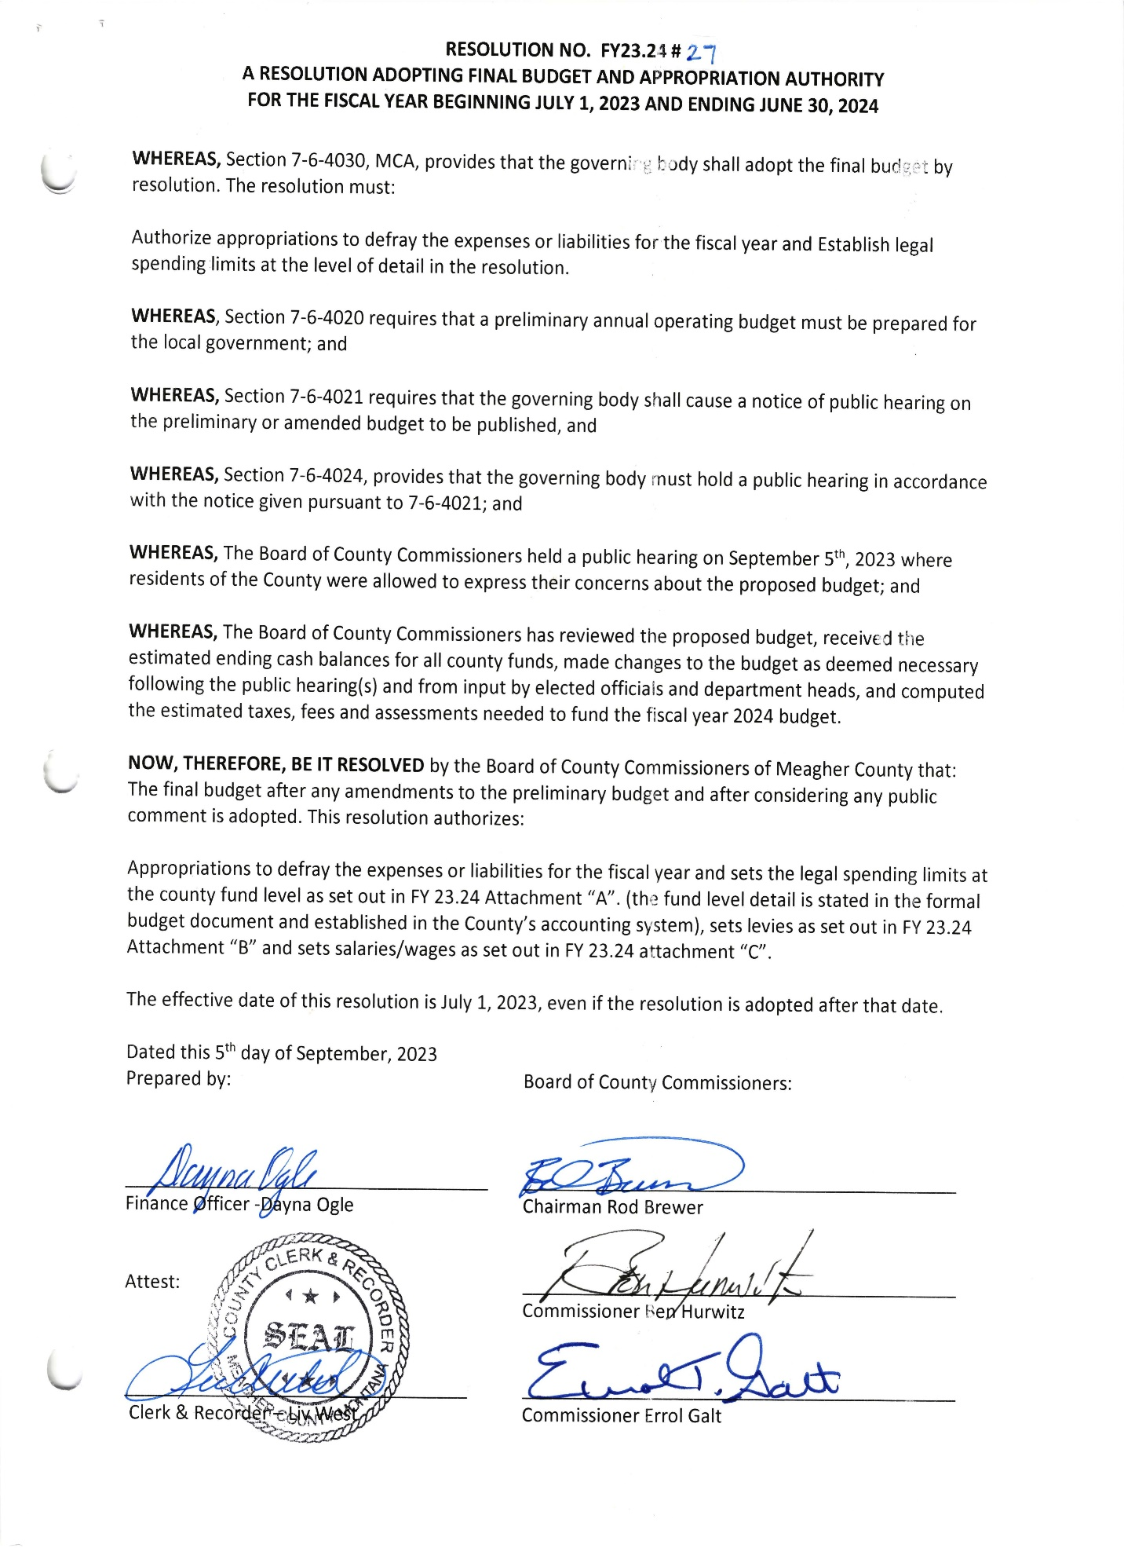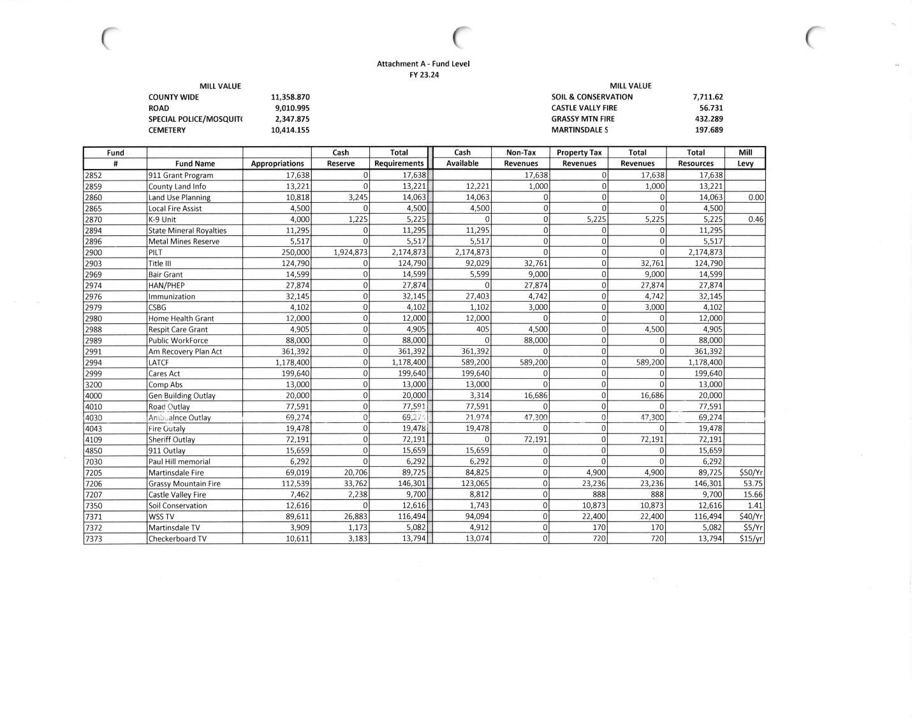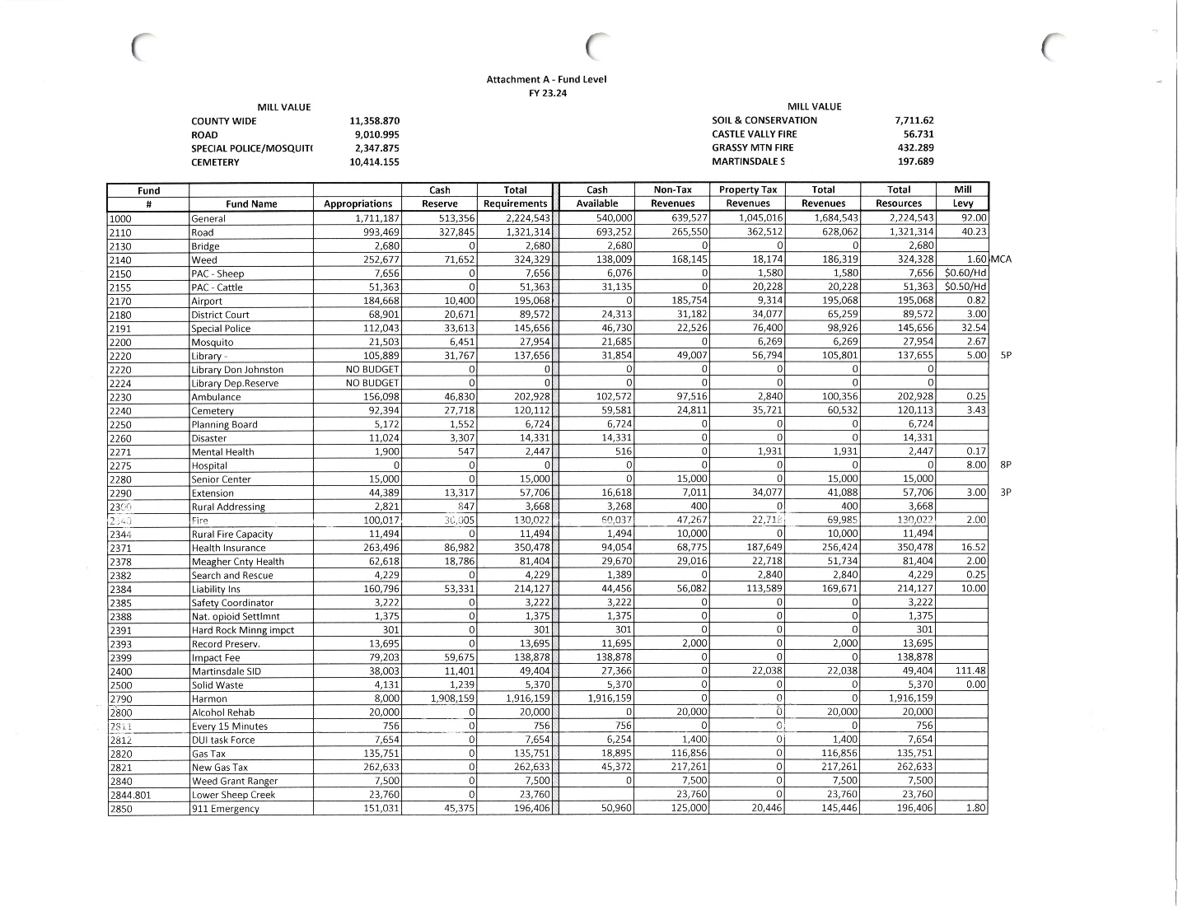

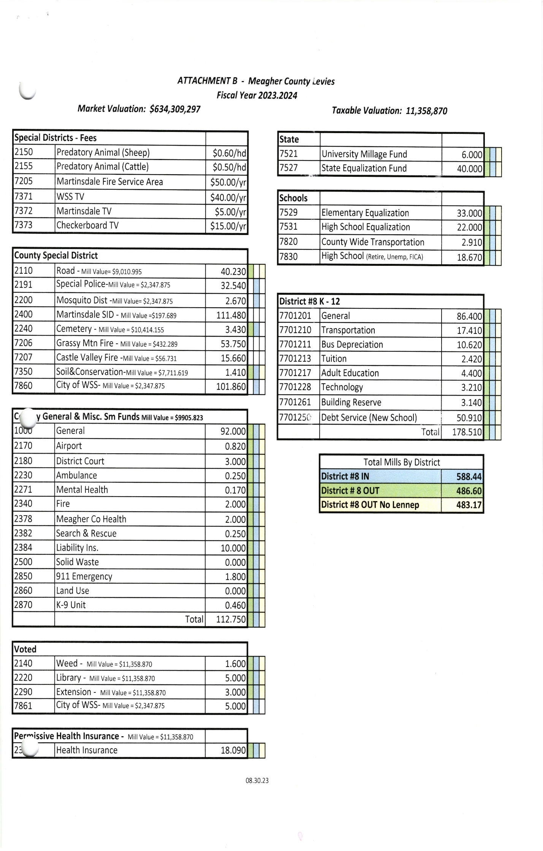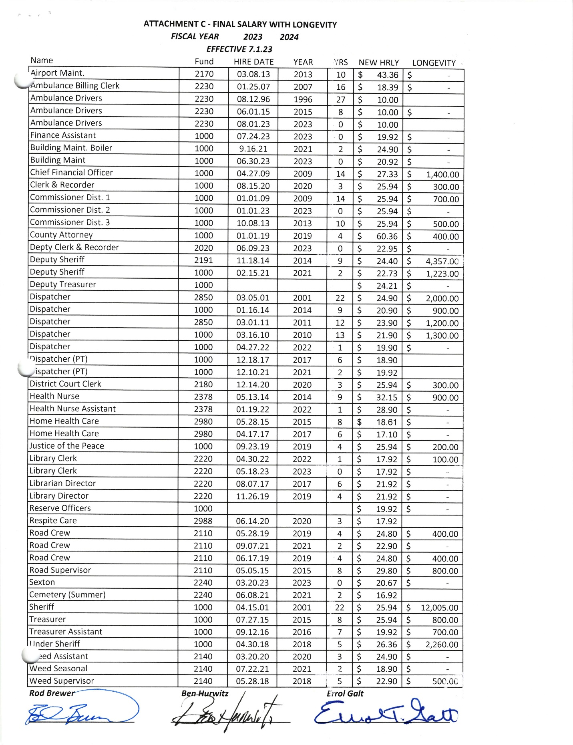

**ACTION # 4**

**Resolution FY 23.24 #28**

Galt moved to give the Sheriff, Under Sheriff, and Deputies $2000/year in Hazard Pay. Brewer seconded. A vote was taken and passed, the issue is hereby resolved.

**ACTION # 5**

**Resolution FY 23.24 #29**

Brewer moved to give elected officials a COLA of 8% or $1.92. All other county employees regardless of probationary status will receive a COLA of $1.92 with the exception of Deputies and the Under Sheriff who receive a percentage of their Elected Officials salary and EMT’s. Hurwitz seconded. A vote was taken and passed, the issue is hereby resolve.

**Public Comment**

No Public Comment

**Claims Approved:**

Commissioners were presented with check # 60655 - # 60685 totaling $51,080.46. All checks were signed as presented.

**Meeting Adjourned:**

Meeting was adjourned at 12:30 p.m.

**Next Meeting:**

Commissioners are scheduled to meet Tuesday, September 12th, 2023.

**CLERK & RECORDER CHAIRMAN**

**SEAL VICE-CHAIRMAN**

**COMMISSIONER**

Note: Minutes taken by Chief Financial Officer Dayna Ogle/ formatted by Clerk to the Commission Jennifer Deems.

Distributed September 5th, 2023 to Chairman Brewer, Vice Chair Hurwitz, and Commissioner Galt, and Clerk & Recorder Liv West.