PROCEEDINGS OF THE BOARD OF THE COMMISSIONERS

MEAGHER COUNTY, MONTANA

Tuesday

May 9th, 2023

8:30 a.m. – 4:00 p.m.

Met in Commissioner’s Chambers

**Meeting Called to Order:**

Chair Brewer called the meeting to order at 8:30 a.m.

**Commissioners Present:**

Chair Rod Brewer, Vice Chair Ben Hurwitz, and Commissioner Errol Galt were present for the meeting.

**Minutes:**

**ACTION #1**

Commissioner Galt moved to approve the minutes from May 2nd, 2023. Commissioner Brewer seconded the motion. A vote was taken and minutes were approved.

**Monthly Health Nurse Report – Eva Kerr:**

Health Nurse Eva Kerr enterer the chambers at 9:00 a.m.

Kerr opened by stating she has received a Bair Grant in the amount of $9000. Kerr will utilize the funding to support her wages and purchasing supplies for the health department.

Kerr reported there was one positive Covid-19 case last month.

Kerr reported she has completed the Kindergarten screening at the elementary school and participated in the Community Expo. Kerr discussed her funding through Human Resource Development Council (HRDC) for FY 23-24. HRDC has a satellite office in White Sulphur Springs and Kerr explained that there are differences in the services provided by each office. Kerr’s focus is to provide immunization, outreach and education to children and lower income families while Taylors focus is providing services to our elderly community.

The Commissioner requested Terry Taylor to be on the agenda to further discuss the services her office provides to Meagher County.

Kerr reported there is potential for the Homemaker and Respit Care programs to go slightly over budget. There is a growing need for both of these services and looking forward Kerr has applied for increased funding for both programs through the Rocky Mountain Development Council, Area IV on Aging.

**Wipfli LLC – FY 20.21 Audit exit Interview – Clayton Johnson:**

Clayton Johnson, Senior Manager Wipfli LLC entered the chambers at 9:15 a.m.

Clerk & Recorder Liv West and Treasurer Maura Kusek entered the chambers at 9:30 a.m.

Johnson opened by introducing himself to the Commission and giving a brief history of Wipfli LLC. Currently Wipfli is a nationwide account/auditing company with approximately 300 employees in the mid-west and around 150 employees in Montana. Johnson has been the director of account for Wipfli for 20 years.

Johnson stated the audit was conducted in accordance with auditing standard generally accepted in the United States and the standard applicable to financial audit contained in Government Auditing Standards. Johnson then reviewed the internal controls over financial reporting and stated he did not identify any deficiencies in internal controls that were considered a material weakness and that there were no instances on noncompliance or other matters that are required to be reported under Government Auditing Standards.

Johnson the reviewed the Basic Financial Statements and Notes to the Financial Statements, pointing out the differences in each statement and the key points in the note disclosures.

Johnson closed by stating this was a clean audit with an unmodified opinion.

**County Attorney Report – Burt Hurwitz**

County Attorney Burt Hurwitz enter the chambers at 10:00a.m.

The meeting was moved to the conference room in the basement.

Hurwitz opened with monthly report, updating the Commission on the recent Planning Board meetings where the board is continuing to pressure the Forest Service on the Castle Mountain /Willow Creek Drainage issues and the board has completed an internal review of the Wildland/Urban Interface Policy. This will be presented to the Commission next week by Secrest Fire Solutions. Hurwtiz updated on the progress for the annexation of the new hospital into the city limits and stated that this is back on track.

Hurwitz then reported on housing and infrastructure issues. The water main replacement project across Townsend Ranch’s pivot is scheduled for next year. The next project will be upgrades to the current sand filter system, and then cleaning and upgrading the current city water reservoir in Willow Creek.

Hurwtiz closed by reporting county criminal matters were pretty quiet this month.

**Grassy Mountain Fire District – Co Attorney Burt Hurwitz**

Grassy Mountain Ranch Owners Assoc President Greg Philpot, Paul Komlosi, Clerk & Recorder Liv West and Temporary Deputy Clerk & Recorder Penny Plachy were present.

Hurwitz opened by discussing the petition Philpott had signed by landowners in Grassy Mountain subdivision last year at their annual meeting and the fact that it did not meet the requirements that Election Administrator/Clerk & Recorder Liv West required in a petition. Philpott stated that even thought it was not a valid petition, it still showed a general consensus that the majority of landowners would like to dissolve the current Grassy Mountain Fire District (GMFD)

Hurwtiz stated the challenges in dissolving the GMFD because it was a requirement of final plat when the subdivision was approved. Hurwitz then explained the difference between a Fire Service Area (FSA) and a Fire District (FD) with the main difference being a FSA is assessed a fee set by the County Commissioner and a FD is taxed on valuation. An FSA can have a board or the Commission can oversee the FSA while a FD must have an elected board in place. Hurwtiz then explained that a FD can be consolidated into a FSA and visa versa. The possibility of creating a FSA and then consolidating the GMFD into the FSA was discussed. The exact location of the FSA was not decided, however Ringling was thought to be a good prospect.

To create a Fire Service area the County would need to have 30 landowner of real property or 51% (majority) of landowner in favor of the FSA.

The Insurance Service Office rating (ISO) was discussed and the possibility of lower insurance rates for landowners if they were in a fire district or a fire service area. The fire trucks and equipment go through an extensive testing to get the ISO rating. Once the rating is established the landowners in the area can submit the rating to their insurance companies.

Philpot asked about the possibility for the GMFD to construct a fire building and have the county maintain the equipment and the facility. The vacancies in the current GMFD board must be filled before any action can take place.

**Commission Work Session:**

Extension Agent Makayla Paul, Clerk & Recorder Liv West, Temporary Deputy Clerk & Recorder Penny Plachy, County Attorney Burt Hurwitz were present.

Paul opened with a review of last week’s work session. She reviewed needs of the county and recognized that the hiring market is not great now and there will be a great need to be flexible in hiring and moving forward.

Commissioner Hurwitz inquired about the roll a Public Information Officer would have. Attorney Hurwitz explained that portion of the FTE would be responsible for all outwardly going communication for the entire county and be responsible for all media contacts, Facebook pages, Nixle etc. Hurwtiz also expressed the need to be flexible in the job duties and to work toward an employee strengths.

Funding for the second FTE was discussed and the impacts that might have on the current budget. ¾ of this position could be potentially be funded through grants leaving only ¼ to be the responsibility of the County.

The Commission discussed the option of posting the Finance Assistant now and waiting until next budget cycle and look at the second FTE, Witness Victim Advocate/ Deputy DES / PIO position at that time.

Finance Officer / HR Dayna Ogle will create a job description and post the job opening when that is complete.

**ACTION #2**

**Resolution Fiscal Year 22.23 - 101**

Commissioner Galt moved to open the Finance Assistant position for applications, Commissioner Brewer seconded. A vote was taken, the motion passes.

**Monthly Cemetery Board Report:**

Cemetery Board members, Rosie Spaulding, Angie Egeler, Kathy Palmer and Sexton Mike Marion were all present.

Spaulding opened by stating the board had conducted interviews for the Seasonal Cemetery Assistant position yesterday. The board offered the job to Signe West and she accepted. HR Dayna Ogle will prepare an employment offer letter and new employee packet for West.

The board discussed the need to better tracking of mileage when the Sexton is using his personal vehicle for County business.

Sexton Marion reported he has picked up the new zero turn lawn mower in Helena and is currently working getting the cemetery ready for the Memorial Day presentation.

**Open Sealed bids – 1991 Chevy Pickup – Cemetery Board:**

Cemetery Board members, Rosie Spaulding, Angie Egeler, Kathy Palmer and Sexton Mike Marion were all present.

One bid was received for the 1991 Chevy Pickup. Spaulding opened bid, Tanner Mitchell bid $501.

Ogle will contact Mitchell to make arrangements for receiving the payment and the transfer of title.

**ACTION #3**

**Resolution Fiscal Year 22.23 - 102**

Commissioner Galt moved to accept the bid from Tanner Mitchell for $501, Commissioner Brewer seconded. A vote was taken, the motion passes.

**County Personal Property Resolution:**

County Attorney Burt Hurwitz entered at 2:15

Hurwitz presented the resolution for Declaring Property Surplus Property and Notifying The Public f Availability.

**ACTION #4**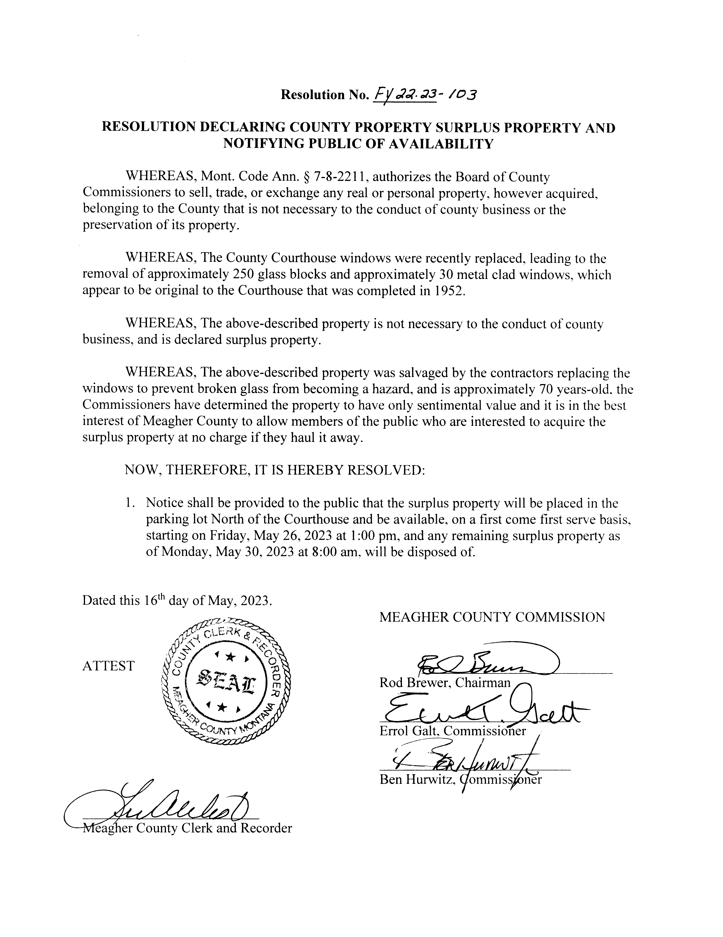

Galt presented an email from a citizen regarding the request for a speed study on Highway 89, Attorney Hurwitz will contact the citizen to let them know the County does not have any authority on a State highway and will suggest the citizen contact the State highway department.

**Library ADA Door Call for Bid – Rachel Wahlstrom**

Library Director, Rachel Wahlstrom entered the chambers at 2:30p.m.

Wahlstrom opened by stating the Library had received a Bair Grant in the amount of $ 12,000 to upgrade the Library front doors to be ADA compliant. Per the Meagher count Purchasing policy Wahlstrom will solicit phone bids for the project.

**ACTION # 5**

**Resolution Fiscal Year 22.23 - 104**

Commissioner Hurwitz moved to allow Library Director Rachel Wahlstrom to solicit phone bids to upgrade the Library front door to be ADA compliant. Commissioner Brewer seconded. A vote was taken, the motion passes.

**Airport / USFS Incident Support Airport Agreement – Airport Board**

USFS Representative Kipp Colby, Airport Board members Kurt Burns and Bill Galt were present, USFS representative Melissa Maestas attended via conference call.

Maestas opened by reviewing the Incident Support Agreement email to the Commission and Airport Board earlier. USFS would like the Board to specify the location and description of how to get to the land/facility. Board member Kurt Burns stated he would like the incident area to have access through the Northeast gate or the West gate and the area would be defined by the main runway on the east side, the cross runway on the south side and the county road on the north and west sides. This would separate the USFS activity from the general airport operations. Board member Bill Galt also stressed no helicopters over 5000 #’s max gross weight and no skidded helicopters are allowed on the tarmac. Board member Galt also stressed the Airport Board and County will not give up the autonomy at the airport.

The question came up as to what happens if other agencies are called to assist. Maestas stated that any other agency within the UFSF and DNRC would fall under this agreement.

Board member Burns and Colby agreed to go out to the airport and look at the proposed site, Attorney Hurwitz agreed to draw up a map outlining the designated areas for the LUA.

**ACTION # 6**

**Resolution Fiscal Year 22.23 - 105**

Commissioner Galt moved to allow Board member Kurt Burns to enter into a 5-year Land Use Agreement with the United States Forest Service. Commissioner Hurwtiz seconded the motion. A vote was taken the motion passes.

**Claims Approved:**

Commissioners were presented with Check # 60296 through Check # 60309 totaling $ 76,317.09. All Checks were signed as presented.

**Meeting Adjourned:**

Meeting was adjourned at 3:40 p.m.

**Next Meeting:**

Commissioners are scheduled to meet Tuesday, May16th 2023.

**CLERK & RECORDER CHAIRMAN**

**SEAL VICE-CHAIRMAN**

**COMMISSIONER**

Note: Minutes taken by Financial Officer Dayna Ogle

Distributed May 16th, 2023 to Chairman Rod Brewer, Vice Chair Ben Hurwitz, and Commissioner Errol Galt, and Clerk & Recorder Liv West.