PROCEEDINGS OF THE BOARD OF THE COMMISSIONERS

MEAGHER COUNTY, MONTANA

Tuesday

January 3rd, 2023

8:30 a.m. – 11:30 a.m.

Met in Commissioner’s Chambers

**Meeting Called to Order:**

Chair Brewer called the meeting to order at 8:30 a.m.

**Commissioners Present:**

Chair Rod Brewer, Vice Chair Ben Hurwitz and Commissioner Errol Galt were present for the meeting.

**Minutes:**

**ACTION #1**

Commissioner Hurwitz moved to approve the Minutes from December 20th, 2022. Commissioner Brewer seconded the motion. A vote was taken and minutes were approved. Commissioner Galt abstained from voting.

**Swearing in of New Elected Officials:**

*Chair Brewer swore in the newly Elected Officials in the Meagher County Courtroom.*

* *Clerk & Recorder – Liv West*
* *County Attorney – Burt Hurwitz*
* *County Commissioner District #2 – Errol Galt*
* *Justice of the Peace – John Lesofski*
* *Treasurer – Maura Kusek*

**Monthly Road/Fire Report—Jake Kusek:**

Road Supervisor Jake Kusek and Fire Volunteer Jerami West entered the chambers at 9:30 a.m.

Fire Volunteer West and Kusek presented the Commissioners with a memorial tribute decal sketch and asked permission to place the decal on the top of the new Fire Chief Truck. Kusek, West, and the Commissioners discussed the memorial tribute decal and the meaning of the different elements. Commissioners approved the placing of the memorial tribute decal but made it a requirement that the family be involved and gives permission for the memorial tribute.

Kusek then updated the Commissioners on the continued work with Gravel Permit writer Eric Urban on the Fort Logan Gravel Pit Application. Kusek and the Commissioners then discussed the plowing snow in the county; a request from a Postal Delivery worker asked if the road crew would be more mindful of not piling snow in front of the mail boxes on county roads for safety concerns. Kusek ended his update on the John Deere Grader Leases, terms of the contract included all maintenance/repairs to the graders minus tires. The graders have an expected delivery date on June 2023.

**County Sprinkler Maintenance/Service Contract – Bill Dutton:**

Maintenance Supervisor Bill Dutton and Custodian Rosie Spaulding entered the chambers at 10:00 a.m. Chief Financial Officer Dayna Ogle entered the chambers at 10:15 a.m.

Dutton updated the Commissioners that the Sprinkler System Maintenance/Service contract with Haugan LLC has ended. Commissioners and Dutton discussed the current condition of the Courthouse sprinkler system, length of contract, and if maintenance was necessary within the contract. Also, how the contract includes work for the library and cemetery systems as well. Commissioners instructed Dutton to have vendors choose the length of contract within a three (3) to five (5) year time range. The following decision was made.

**ACTION #2**

**Resolution Fiscal Year 22.23 - #69**

Commissioner Hurwitz moved to grant Dutton the ability to solicit bids for a three (3) to five (5) year Sprinkler Maintenance/Service Contract for Meagher County. Commissioner Galt seconded the motion. A vote was taken and passed. The issue is hereby resolved.

Bids will be opened and reviewed on Tuesday February 7th, 2023 at 10:00 a.m.

Dutton then updated the Commissioners on the County Boiler Systems and his decision to not purchase and install the automatic chemical machine. Dutton stated that he chose not to install/purchase the automated systems due to unexpected increases in the cost and training of the units.

**County New Year’s Resolutions:**

Clerk Luchterhand presented the Commissioners with the New Year’s Resolutions for the County.

**ACTION #3**

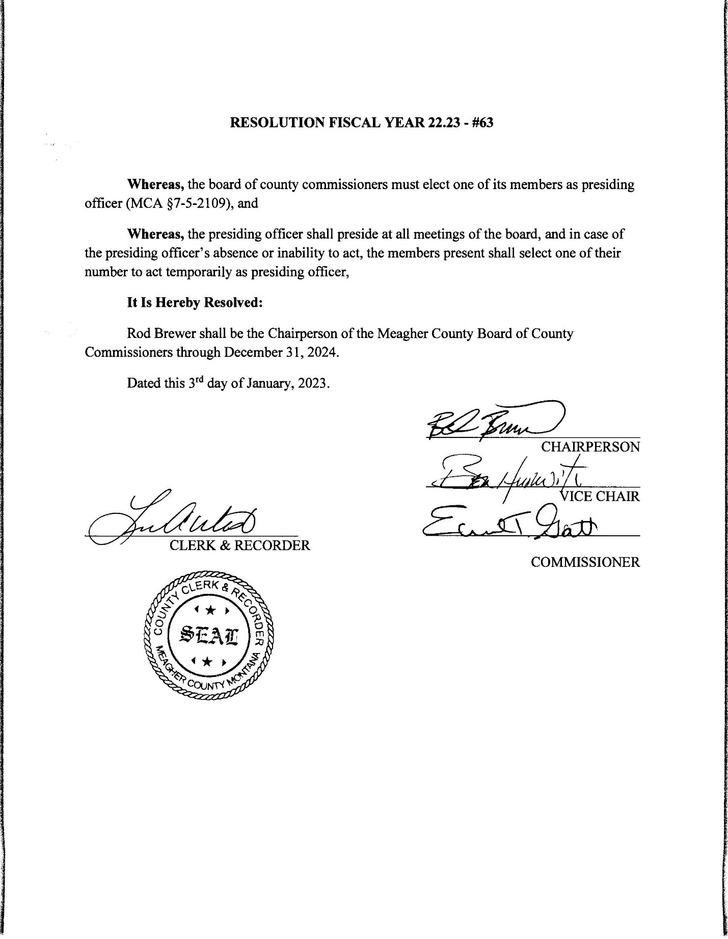

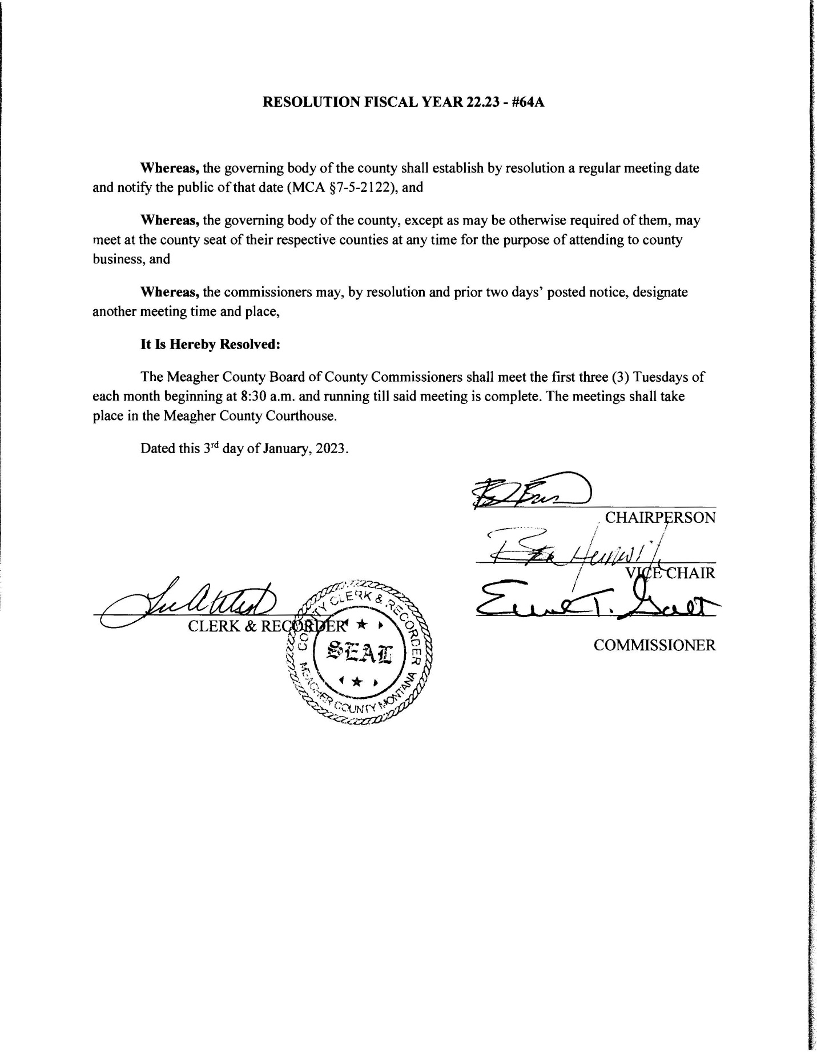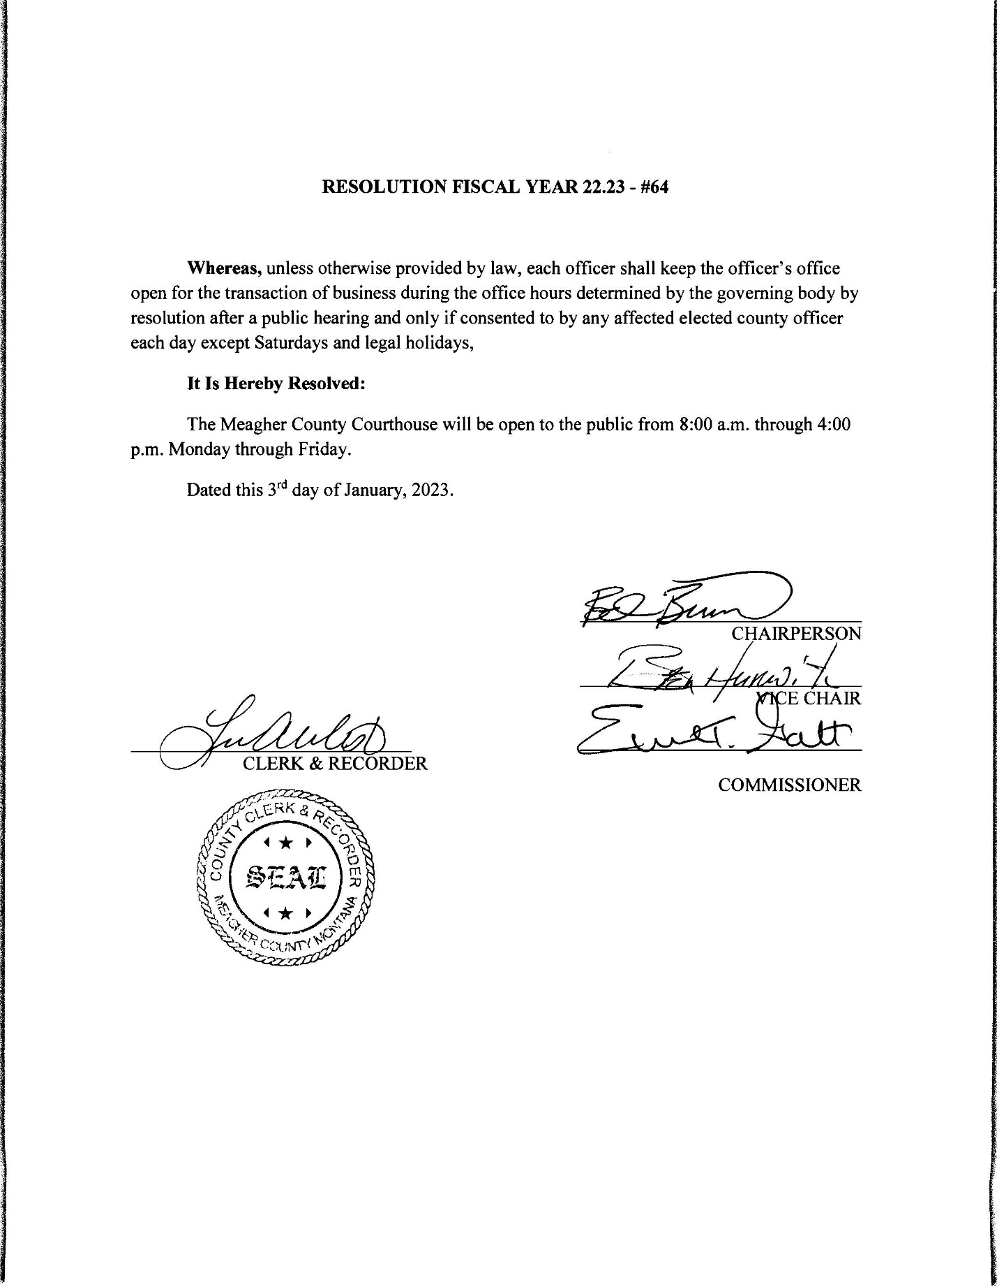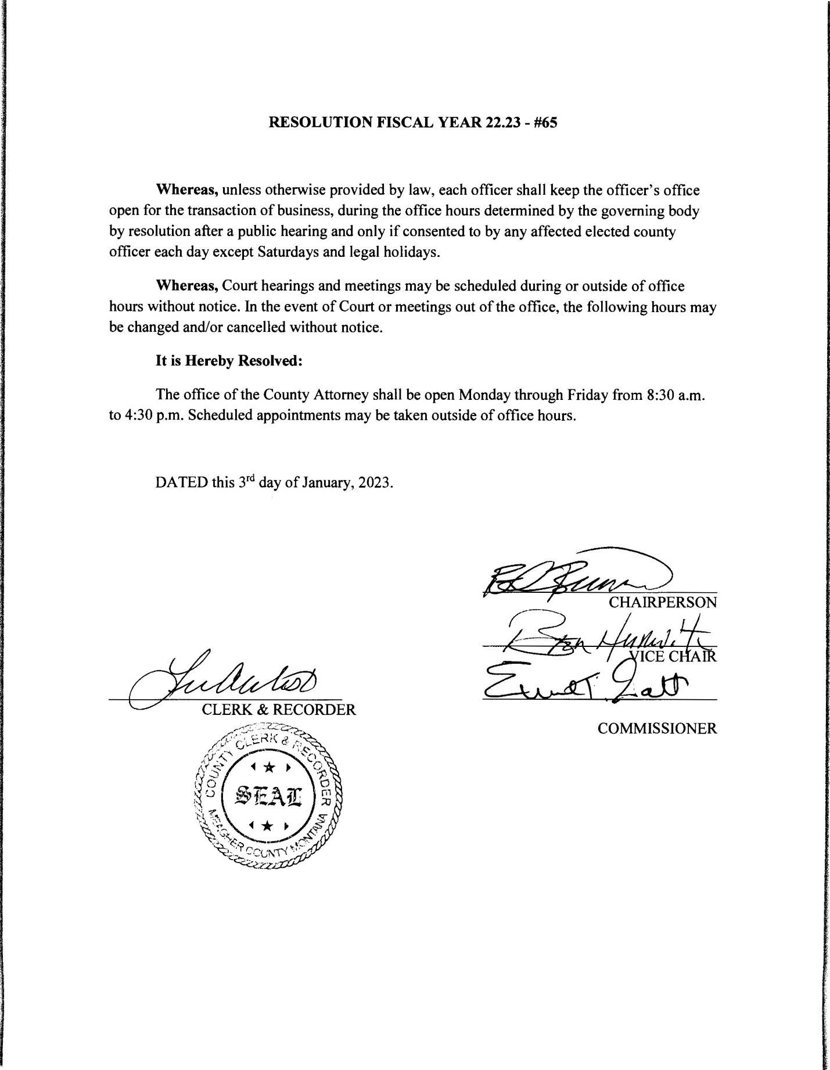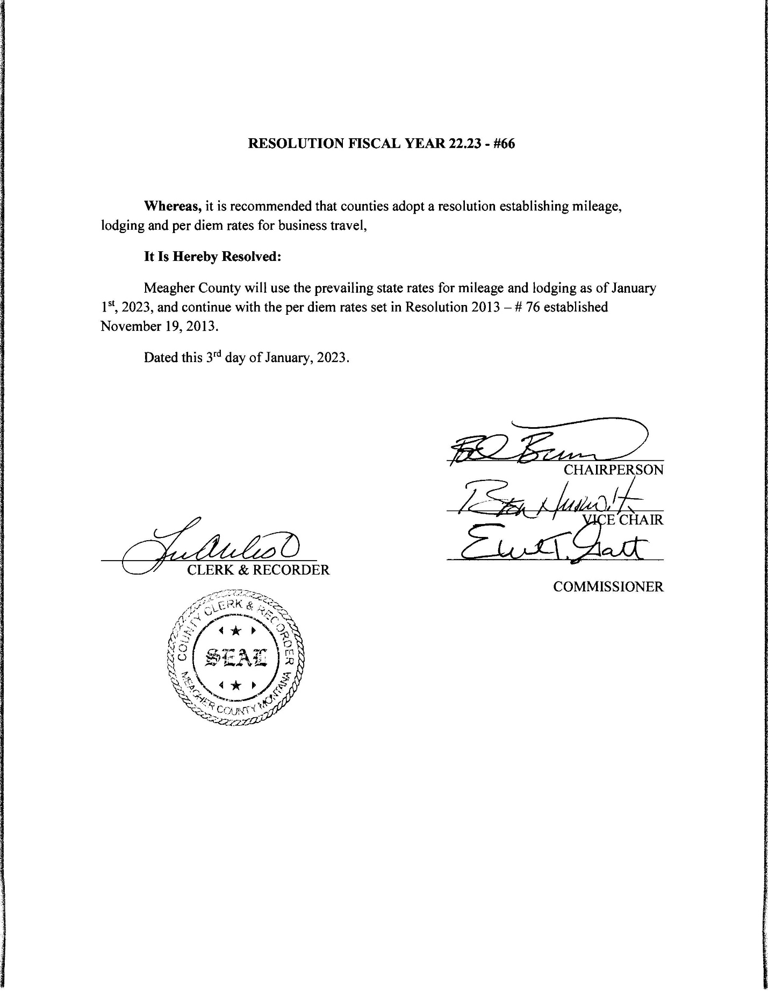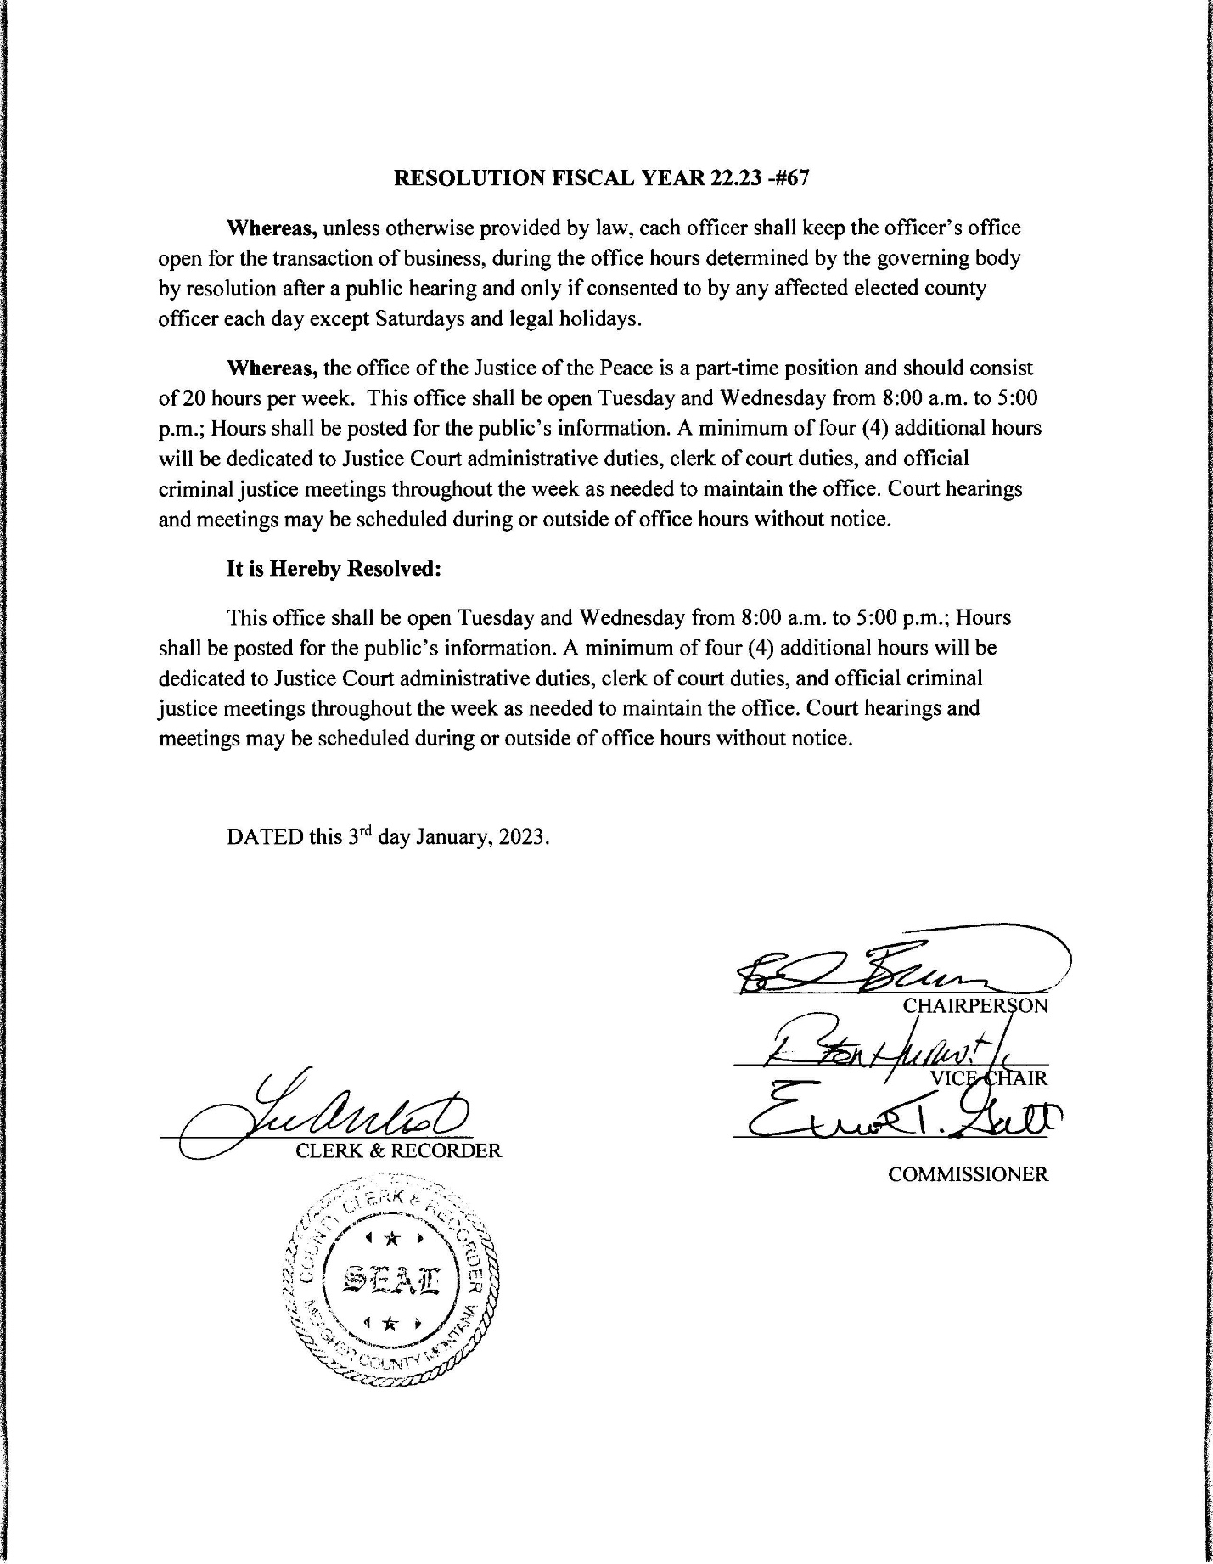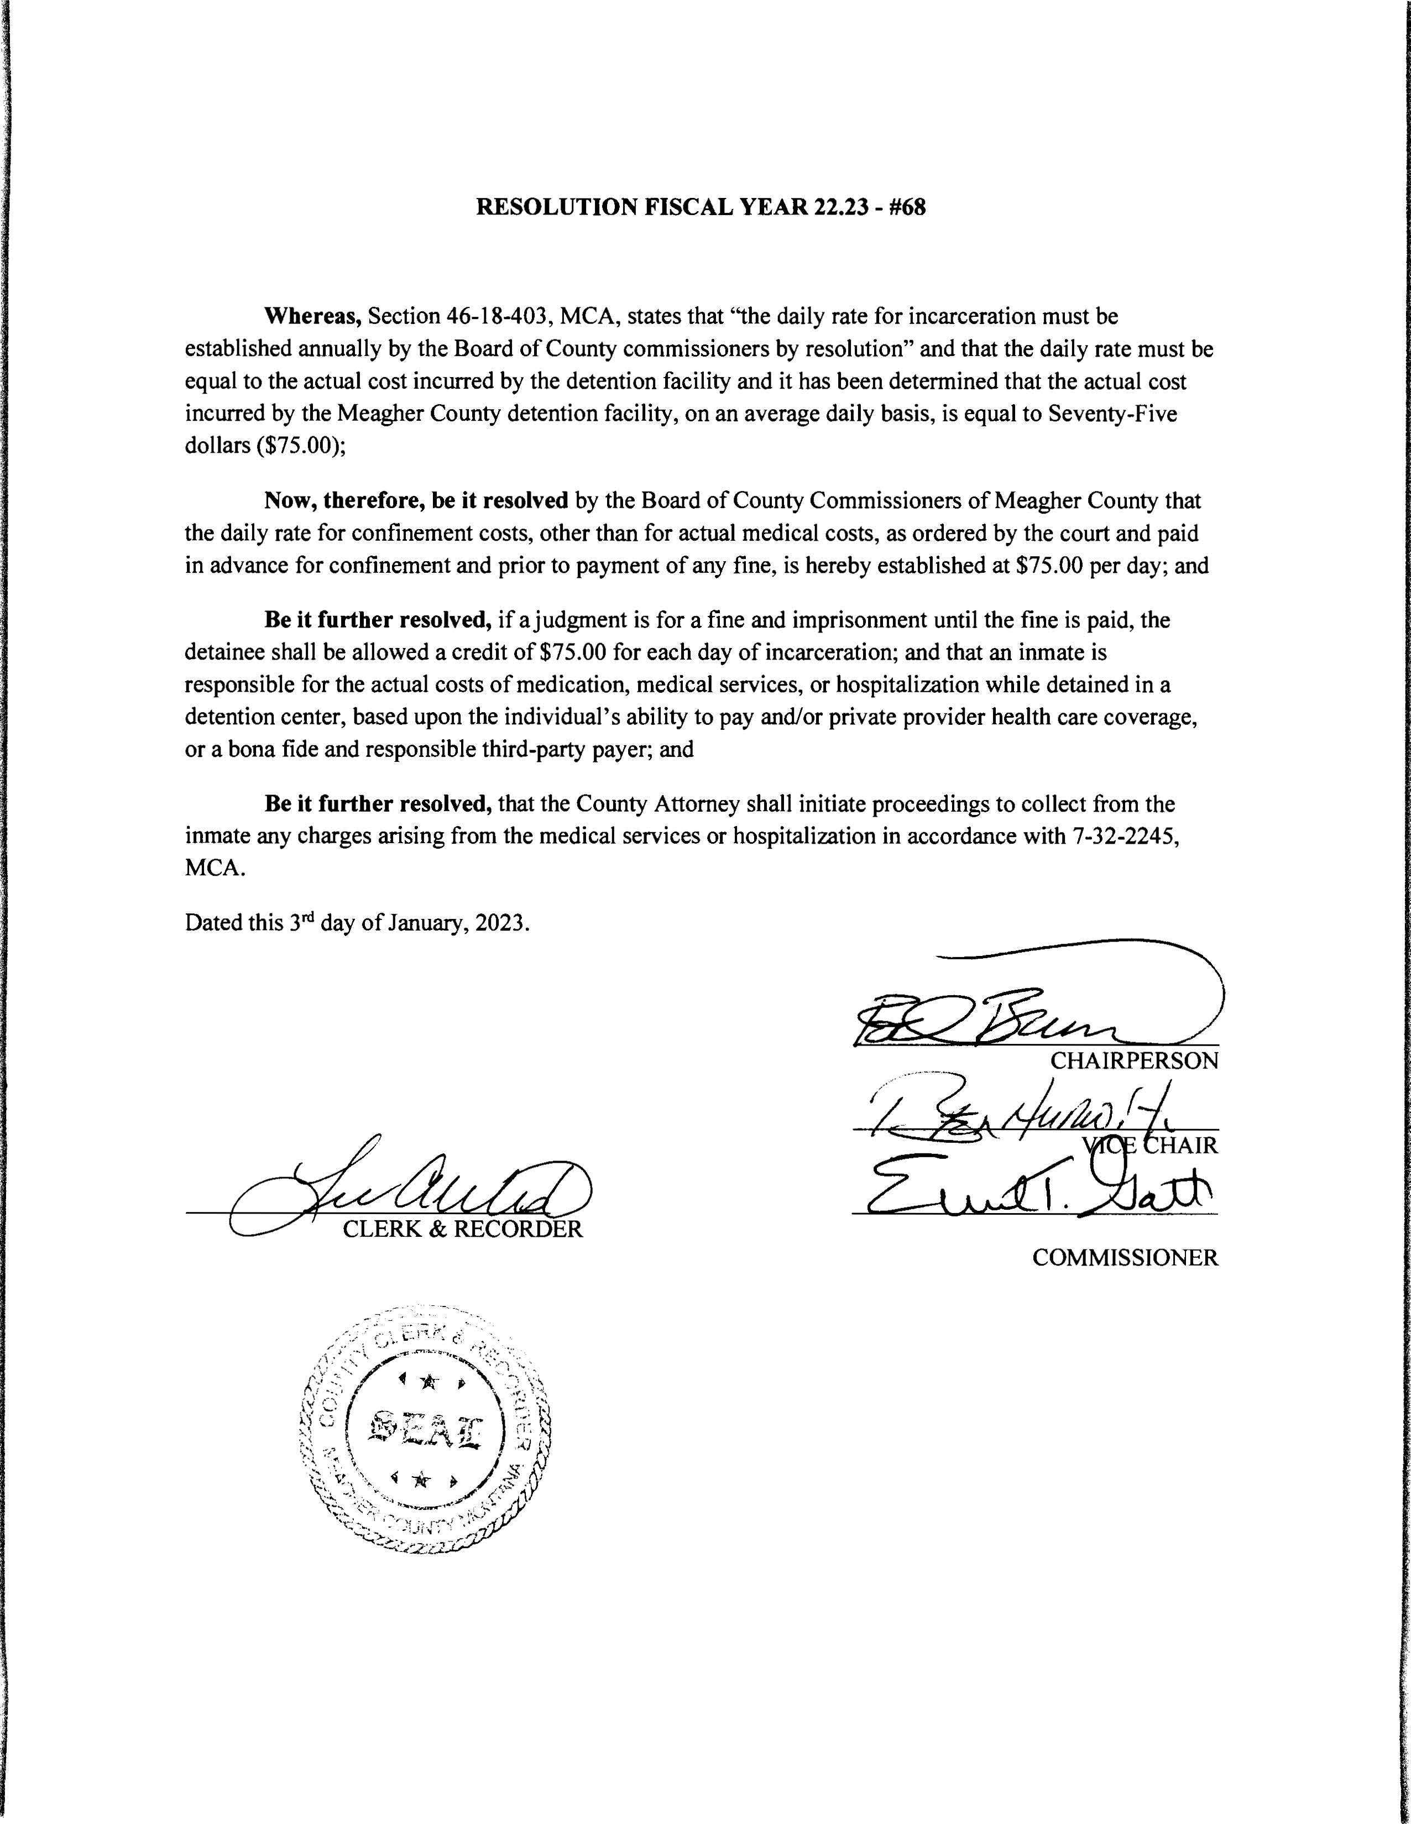

**Open Sealed Request for Proposals (RPF) New Ambulance – Ambulance Board:**

Ambulance Board Member Jack Berg and Chief Financial Officer Dayna Ogle entered the chambers at 11:00 a.m. Steve Apgar conferenced called into the meeting at 11:25 a.m.

Berg was presented with one (1) sealed Request for Proposal (RFP). The RFP was from R.E.S. APGAR Ambulance for $257,911 for a 2023 or newer Dodge 4500 Ambulance with a delivery date of four hundred (400) days. Berg, Ogle, and the Commissioners briefly went through the RFP package and came up with specific questions before further review; main concern was the price and if a down payment was necessary to secure the present price. Apgar explained the price for the ambulance would not change over the 400 days but may have a variation cost for shipping. Apgar stated that the ambulance is equipped with the proper plates necessary to mount/secure the Stryker Power Cot or Stryker Power Load in accordance with Change Notice 7-12 for 5G Crash Retention. Apgar ended discussion with stating that the company has four (4) ambulances that they loan as needed and would be available to Meagher County if necessary while waiting on the ordered ambulance. Commissioners tabled any decision on the presented RFP package until the January 10th, 2023 meeting to allow the Ambulance Board to review the package.

**Public Comment:**

No Public Comment.

**Claims Approved:**

Commissioners were presented with Check #59909 through Check #59935 totaling $18,165.38. All Checks were signed as presented.

**Meeting Adjourned:**

Meeting was adjourned at 12:00 p.m.

**Next Meeting:**

Commissioners are scheduled to meet Tuesday, January 10th, 2023.

**CLERK & RECORDER CHAIRMAN**

**SEAL VICE-CHAIRMAN**

**COMMISSIONER**

Note: Minutes taken by Clerk to the Commission Rebekah Luchterhand

Distributed January 10th, 2023 to Chairman Brewer, Vice Chair Hurwitz, and Commissioner Galt, and Clerk & Recorder West.