PROCEEDINGS OF THE BOARD OF THE COMMISSIONERS

MEAGHER COUNTY, MONTANA

Tuesday

April 4th, 2023

12:30 p.m. – 3:30 p.m.

Met in Commissioner’s Chambers

**Meeting Called to Order:**

Vice Chair Hurwitz called the meeting to order at 12:30 p.m.

**Commissioners Present:**

Vice Chair Ben Hurwitz were present for the meeting. Chair Rod Brewer and Commissioner Errol Galt was absent

**Minutes:**

Tabled until the April 11th, 2023 meeting.

**Monthly Sheriff Report – Jon Lopp:**

Sheriff Jon Lopp and Chief Financial Officer Dayna Ogle entered the chambers at 1:00 p.m.

Lopp presented Commissioner Hurwitz the Complaint Report for March 2023 and an Emergency Proclamation. Lopp stated that there is a high potential for flooding in Meagher County with current projected weather reports. Lopp, Ogle, and Commissioner Hurwitz discussed the necessary steps with proclaiming an emergency, the declaration of an emergency, and the ability to assess two (2) emergency mills per MAC 10-3-405 if required. The following took place.

**ACTION #1**

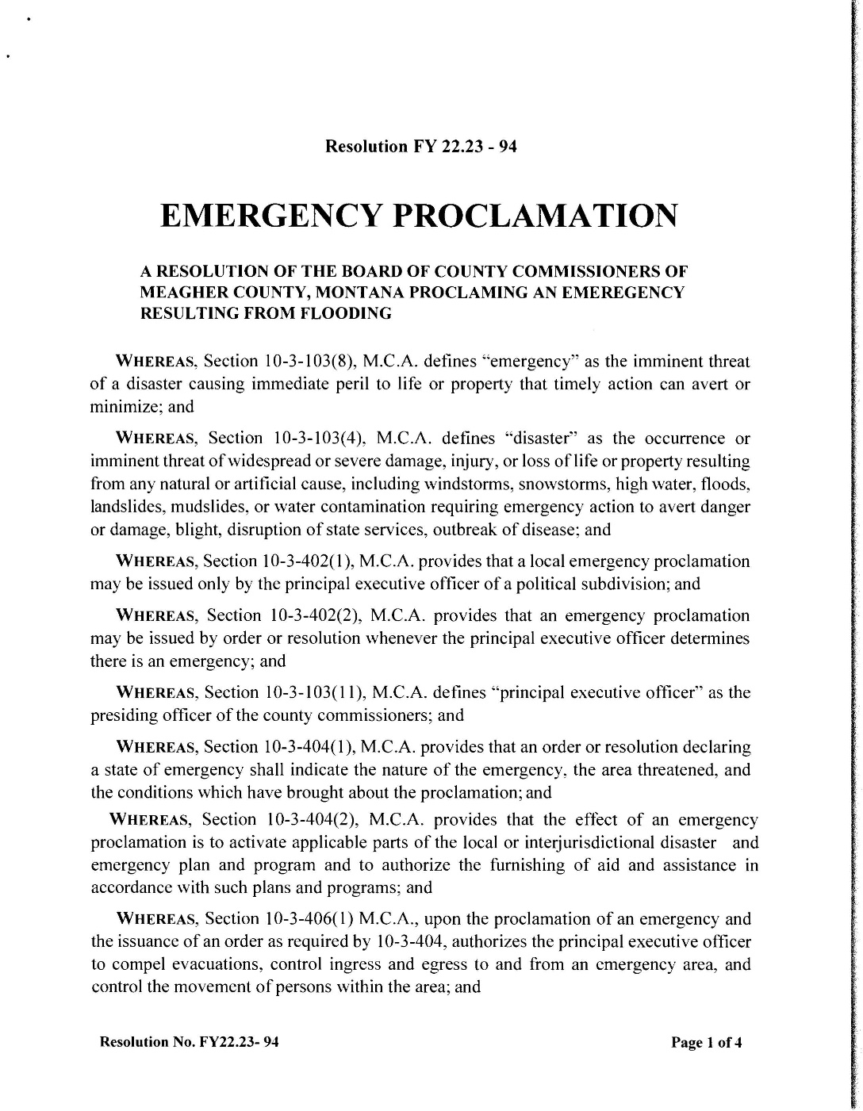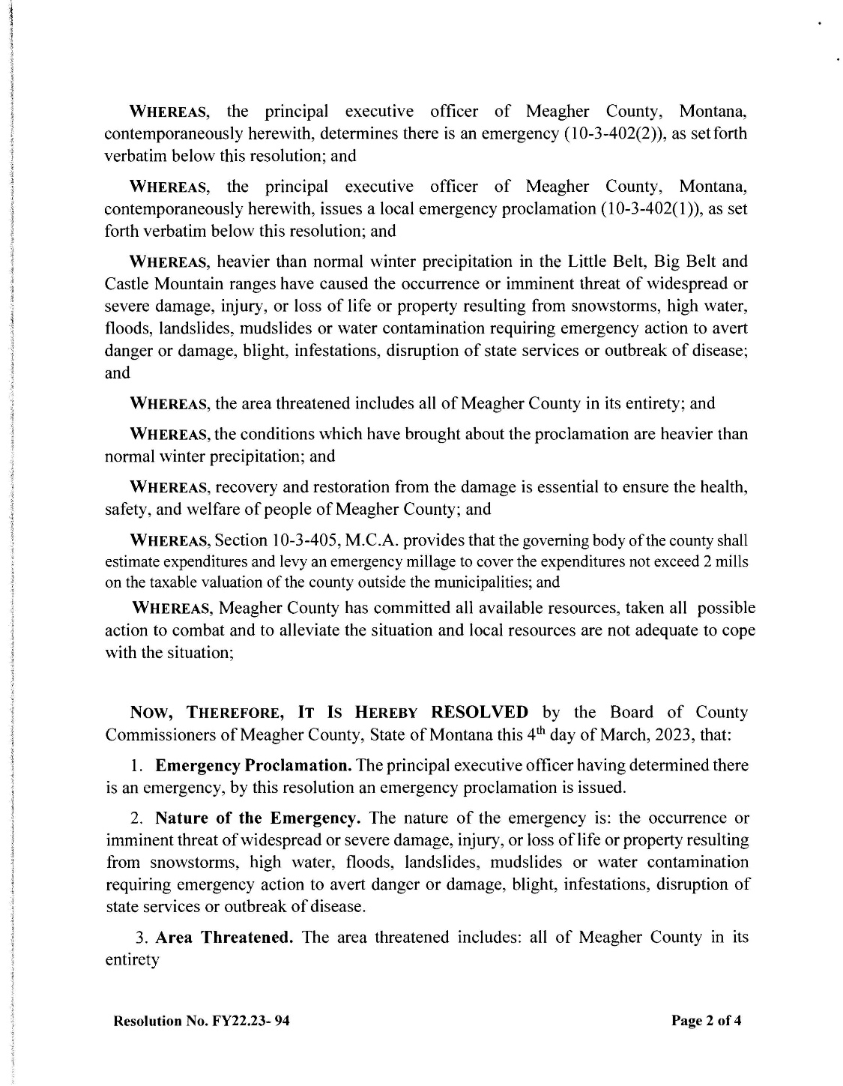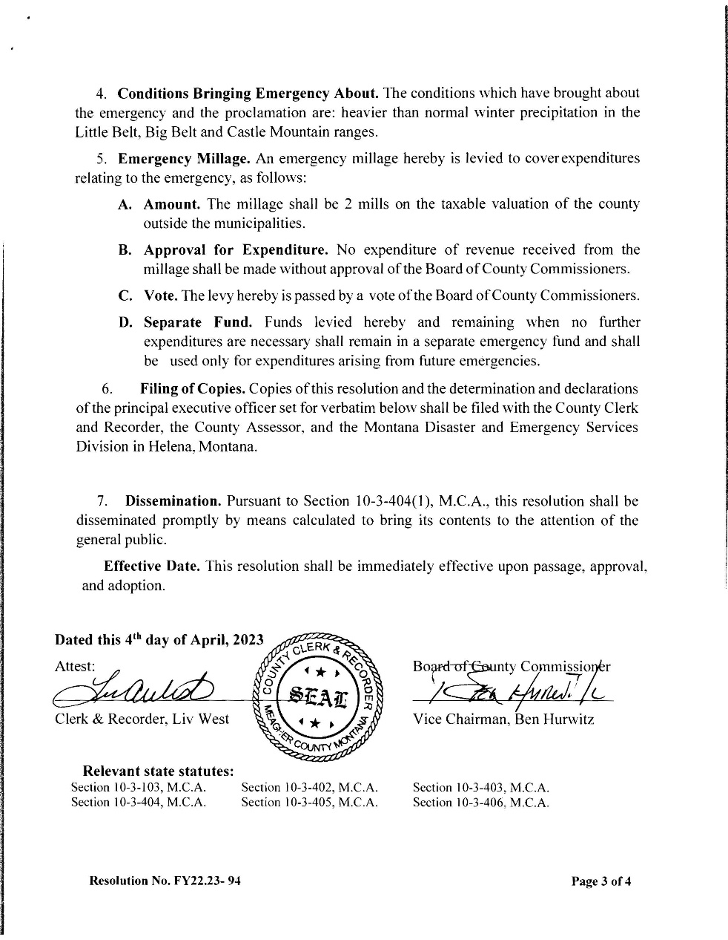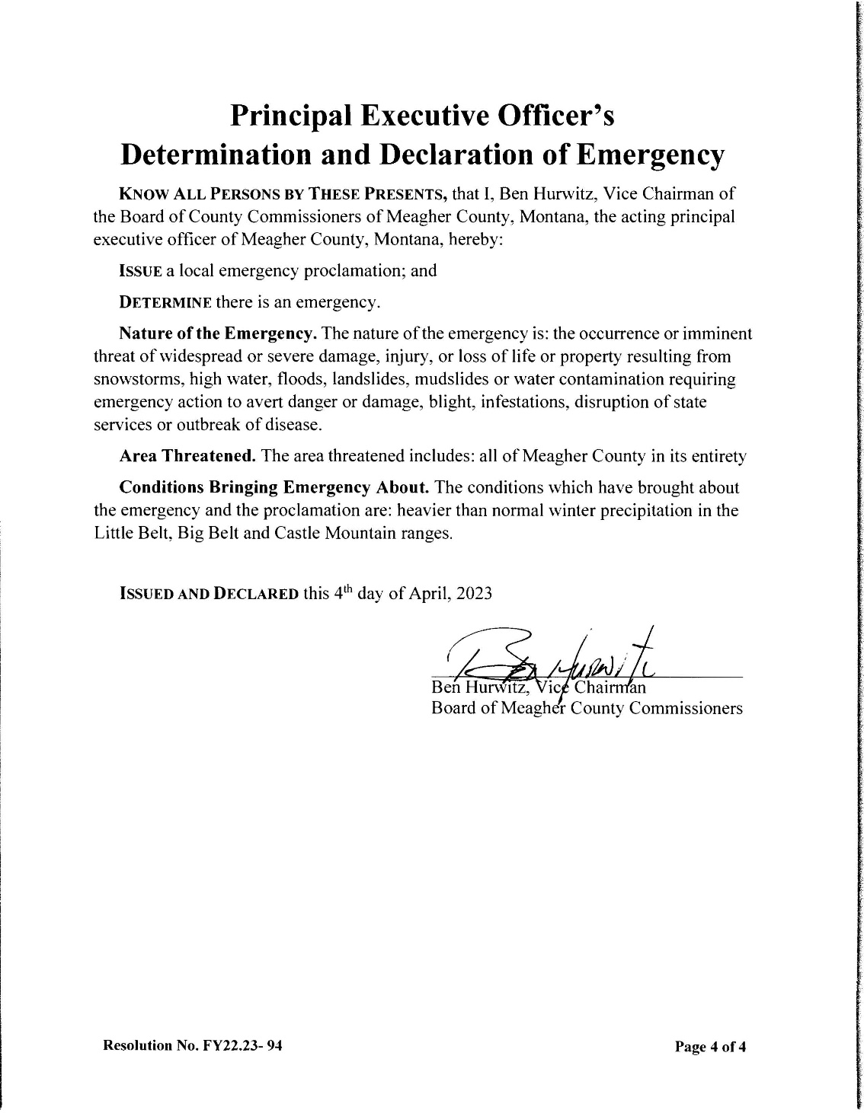

**Community Wildfire Protection Plan – Jess Secrest:**

Jess Secrest entered the chambers at 1:50 p.m.

Secrest updated Commissioner Hurwitz that he is working on the Community Wildfire Protection Plan. At this point in the draft, he is working with utility companies on their fire mitigation procedures. Secrest then stated that on April 19th, 2023 he will be attending a training hosted by the Forest Service on the Potential Operational Delineations (PODS) and will be referencing the PODS within the Community Wildfire Project draft. Training will be going over fire mitigation topics and areas of concern for fuel mitigation within the Lewis & Clark National Forest. The draft will be ready for review in May 2023. Secrest and Commissioner Hurwitz discussed the upcoming Forest County Summit taking place on May 3-4,2023 in Helena Montana.

**Monthly Road Report – Jake Kusek:**

Road Supervisor Jake Kusek entered the chambers at 3:00 p.m. Clerk & Recorder Liv West entered the chambers at 3:15 p.m.

Kusek presented Commissioner Hurwitz with two (2) bridge reports. Kusek stated that the reports are about the Ringling Bridge and the Cottonwood Creek Bridge. Both bridges will require maintenance work which can be completed by the department. Kusek then stated that the installation of the safety lights ad radios to the new Road/Fire Truck should be completed by mid-April 2023. Discussion took place about the county wide clean up day. West stated that Clean-Up Day will be held on Saturday May 13th, 2023 from 8:00 a.m. – 4:00 p.m.

**Public Comment:**

No Public Comment.

**Claims Approved:**

Commissioners were presented with Check #60187 through Check #60224 totaling $45,278.72. All Checks were signed as presented.

**Meeting Adjourned:**

Meeting was adjourned at 4:00 p.m.

**Next Meeting:**

Commissioners are scheduled to meet Tuesday, April 11th, 2023.

***Absent***

**CLERK & RECORDER CHAIRMAN**

**SEAL VICE-CHAIRMAN**

***Absent***

**COMMISSIONER**

Note: Minutes taken by Clerk to the Commission Rebekah Luchterhand

Distributed April 11th, 2023 to Chairman Brewer, Vice Chair Hurwitz and Commissioner Galt, and Clerk & Recorder West.