PROCEEDINGS OF THE BOARD OF THE COMMISSIONERS

MEAGHER COUNTY, MONTANA

Tuesday

April 18th, 2023

12:30 p.m. – 5:00 p.m.

Met in Commissioner’s Chambers

**Meeting Called to Order:**

Chair Brewer called the meeting to order at 12:30 p.m.

**Commissioners Present:**

Chair Rod Brewer, Vice Chair Ben Hurwitz, and Commissioner Errol Galt were present for the meeting.

**Minutes:**

**ACTION #1**

Commissioner Galt moved to approve the Minutes from April 11th, 2023. Chair Brewer seconded the motion. A vote was taken and minutes were approved.

**Alcohol Tax Monies Designation:**

Justice of the Peace John Lesofski, City Court Judge Lori Sorenson, Mayor Rick Nelson, Chief Financial Officer Dayna Ogle, and County Attorney Burt Hurwitz entered the chambers at 1:00 p.m. Southwest Chemical Dependency Representative Jean McCauley, Southwest Chemical Dependency Representative Grandville Boone, and STARR Representative Jean Starr attended via ZOOM Teleconferencing.

Commissioners requested that Southwest Chemical Dependency explain their services they provide for Meagher County. Boone and McCauley stated that the ACT Class costs $325 through their company. If the person travels from White Sulphur Springs to take the course $100 is taken off the cost to help with travel. Southwest Chemical Dependency does not offer virtual classes and does not have a person on staff to come to Meagher County at this time. McCauley stated that the funding received goes towards the salaries of the counselors employed, funding towards their recovery house program, and supplies. Meagher County has been with Southwest Chemical Dependency since about the 1980s.

Commissioners then asked STARR to explain the services that they could provide to Meagher County. Starr explained her pre-presented letter and how her company utilizes virtual technology to help serve more rural areas. Starr also stated, that the designated monies would be used to purchase iPads to setup in each court office for those sentenced to ACT classes to complete their course. Also, that she would provide quarterly updates to the Commissioners on the utilization of designated monies within Meagher County.

Commissioner then asked for the opinions of City Judge Sorenson and Judge Lesofski. Both Judge Sorenson and Judge Lesofski expressed their concerns about how the monies should be utilized for programs that benefit Meagher County and those needing help. Judge Sorenson and Judge Lesofski explained that maybe one third of the DUIs in Meagher County are actually residents.

Lengthy discussion took place on how the monies allocated should be directly serving those in Meagher County and what those options could be. Commissioners requested that JP Lesofski, Judge Sorenson, County Attorney Hurwitz, and Ogle complete more research on how the monies could allocated before hey have to submit their decision to the State on June 16th, 2023.

**Monthly Treasurer Report – Maura Kusek:**

Treasurer Maura Kusek entered the chambers at 1:45 p.m.

Kusek presented the Commissioners with the March 2023 Cash Report, current tax delinquency list, and the first quarter Harmon Fund Report for 2023. Kusek brought up discussion about the earnings and losses of the Harmon Fund Portfolio from 2020 to current. Kusek questioned the projected earnings of $39,717 the portfolio for calendar year 2023 presented by Bill Northey and Jason Jewett. Earnings after the first quarter of 2023 was $102,132.42. Commissioners and Kusek discussed other types of investment programs that Meagher County could place the Harmon Fund monies within.

**Hard Rock Mining Impact Plan Annual Monitoring – Jackson Rose & Nancy Schlepp:**

Black Butte Copper Project Representative Nancy Schlepp, Jackson Rose, Mayor Rick Nelson, and Chief Financial Officer Dayna Ogle entered the chambers at 2:00 p.m.

Rose presented the Commissioners with the draft Hard Rock Mining Impact Plan Annual Monitoring information for 2023. Rose gave a brief history about the Hard Rock Mining Impact Plan and the impact monies received by both the County and City to date. Rose explained that the local government entities have received all monies available since the permit was issued in the summer of 2020. Unfortunately, the project is still considered in Phase 1 of construction because of the pending lawsuits. Discussion took place about how the local government entities could request more impact monies in future since there is a delay in the mine’s actual operation. The money would be handled as a grant from the Black Butte Copper Project through the Montana Department of Commerce. The monies would still be treated as tax pre-payments

Schlepp ended the report with an update on the DQ vs. Trout Unlimited case at the Supreme court. At this time the Supreme Court is deciding whether or not to take oral arguments on the case. Black Butte Copper Project is hopeful for movement towards a decision within the 2023 calendar year.

**Monthly Library Report – Rachel Wahlstrom:**

Library Director Rachel Wahlstrom entered the chambers at 2:30 p.m.

Wahlstrom updated the Commissioners on Dolly Parton’s Imagination Library Program that will be part of the Meagher County/City Library in the near future. Dolly Parton’s Imagination Library Program focuses on providing books to children in rural areas. Wahlstrom stated that the library received a Pilcrow Foundation grant of $1,200 to help purchase books for the children through young adult section of the library. Wahlstrom and the Commissioners then discussed the Wireless Hot-Spot program; the program will remain funded by the State of Montana for another two (2) years. Wahlstrom ended her update with the vacant clerk position at library.

**Monthly Clerk & Recorder Update – Liv West:**

Deputy Clerk & Recorder Penny Plachy entered the chambers at 3:00 p.m.

Plachy updated the Commissioners on the Superintendent of Schools Contract with Susan Beley and how the office is waiting to receive of the original for the Commissioners to sign. Plachy also stated that the Clean-Up Day is scheduled for Saturday May 13th, 2023. Plachy requested that the Commissioners grant County Employees who volunteer half a day work (4 hours) during Clean-Up be given 8 hours compensatory time to use at a later date. Plachy also updated the Commissioners that the City would like a similar resolution for County Employees that volunteered for the Spay/Neuter Clinic. The following decision was made.

**ACTION #**

**Resolution Fiscal Year 22.23 - #99**

Commissioner Hurwitz moved to grant County Employees who volunteer half a day work (4 hours) during Clean-Up be given 8 hours compensatory time to use at a later date. Chair Brewer seconded the motion. A vote was taken and passed. The issue is hereby resolved.

Plachy ended the updated on the upcoming Municipal Elections and her resignation from the Temporary Deputy Clerk & Recorder position. Plachy’s last day within the Clerk & Recorder’s office will be June 26th, 2023.

**Senator Steve Daines Office Update – John Durnal:**

U.S. Senator Steve Daines Representatives John Durnal and Brett Slaughter entered the chambers at 3:30 p.m.

Durnal and Slaughter updated the Commissioners on Senator Daines current work in the U.S. Senate. Slaughter and Durnal asked the Commissioners if they had any concerns to take back to the Senator’s Office. Commissioners expressed their concerns of authority when it comes to fire suppression on the US Forest Lands during wildfires. Slaughter stated that Senator Daines just started a Forest Service Wildfire Coccus that will focus on procedures of fighting wildfires and managements efforts in the west. Discussion ended on the RY Timber Saw Mill located in Livingston, Montana, mainly the negative effects of its closure on the timber markets.

**Airport/USFS Land Use Agreement – Kurt Burns:**

Airport Manager Kurt Burns, Chief Financial Officer Dayna Ogle, Bill Galt entered the chambers at 4:30 p.m. Forest Service District Ranger Helen Smith, District FMO Kip Colby, Jay Lindgren, and Forest Service Contract Specialist Melissa Maestas attended via ZOOM Teleconferencing.

Maestas introduced herself and stated that the goal for the meeting today is to review and complete a Land Use Agreement between the US Forest Service and the White Sulphur Springs Airport. Maestas stated that the Forest Service is looking to have a standing land use agreement with terms of three (3) to five (5) years. Burns asked if the land use agreement could be modeled after the incident land use agreements utilized during the 2021 Fire Season. Maestas stated that the incident land use agreements cannot be used because it was written for a specific incident. Ranger Smith asked if the Commissioners had a current draft of the proposed agreement. Commissioners stated they did not. Ranger Smith requested that the Commissioners be provided with a draft and a new meeting scheduled to finalize at a later date.

Maestas will send the draft agreement to Clerk Luchterhand for the Commissioners and Airport Manager Burns to review. Once the Commissioners received the draft and review the document a meeting will be scheduled with the Forest Service to finalize the contract.

Brief discussion took place about the necessity of helicopter pads at the White Sulphur Springs Airport.

**Amend Resolution 2018-61/ 2018-62/ 2018-63 – NEI Application – Gordon Butte Wind Farm, 71 Ranch LP:**

Ogle presented the Commissioners with Amended Resolutions 6018-61, 2018-62, and 2018-63. Ogle stated that when the original resolutions for the Tax Abatements were approved the abatement timeline was incorrectly calculated. The amended resolutions are to correct the timeline of the abatements. Commissioner Galt abstained from signing due to a conflict of interest.

**ACTION #3**

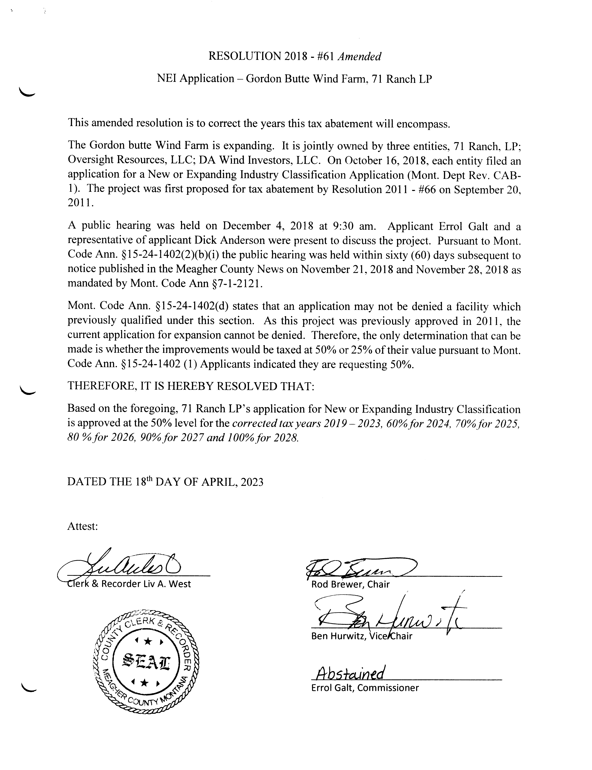

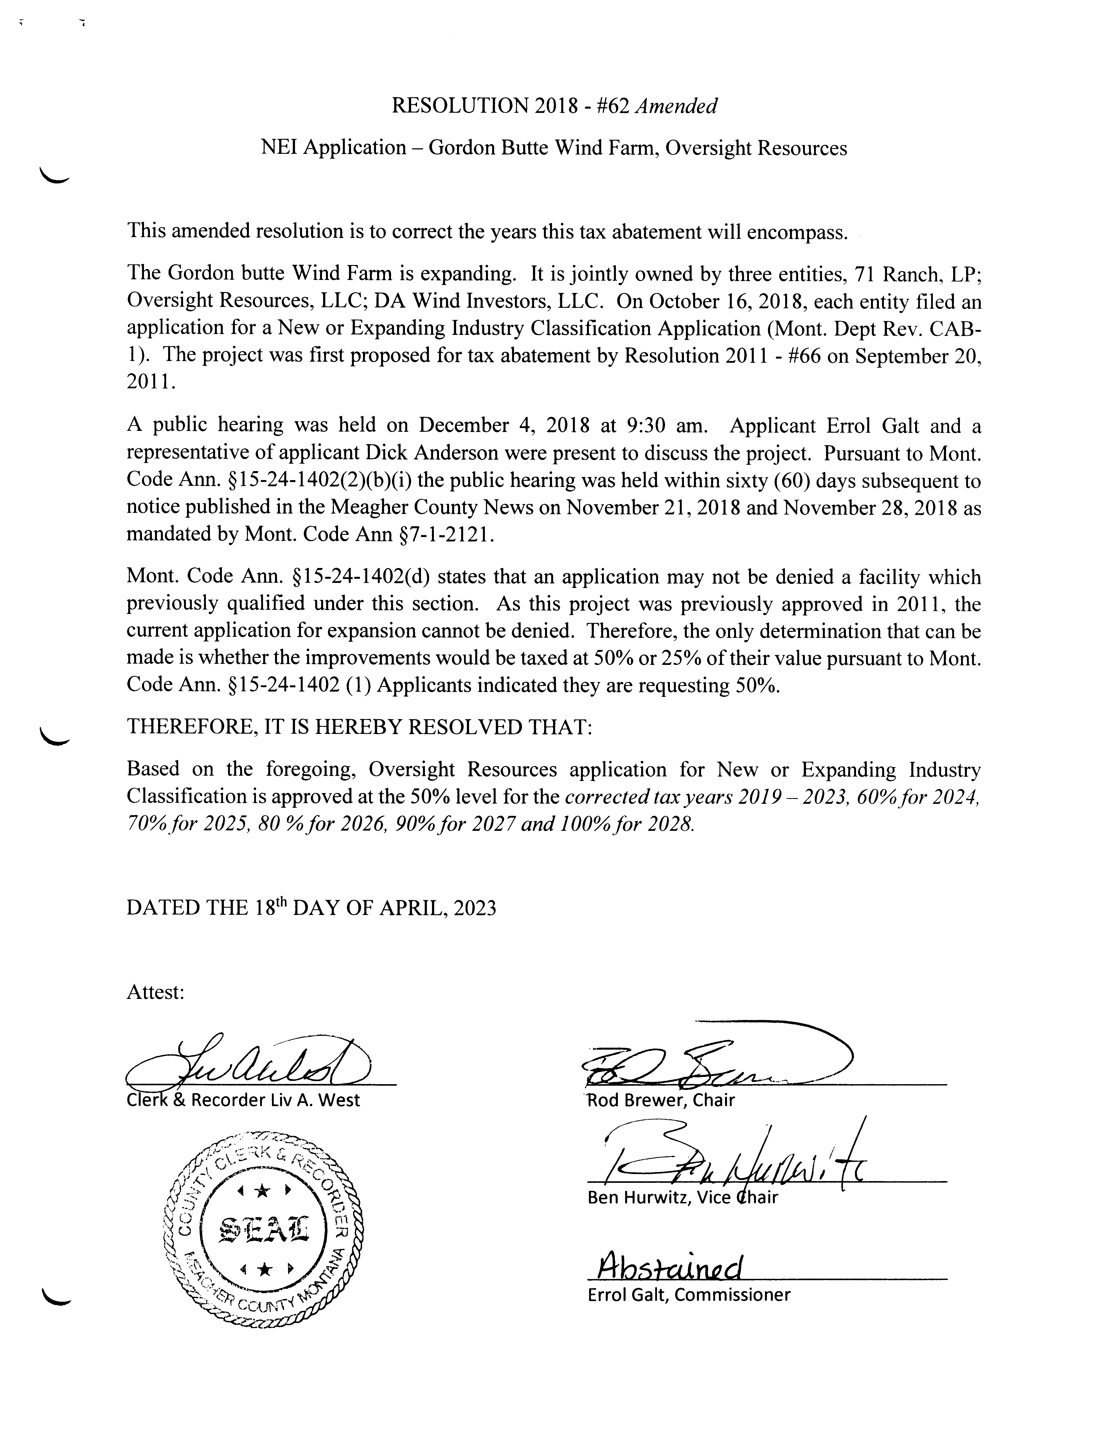

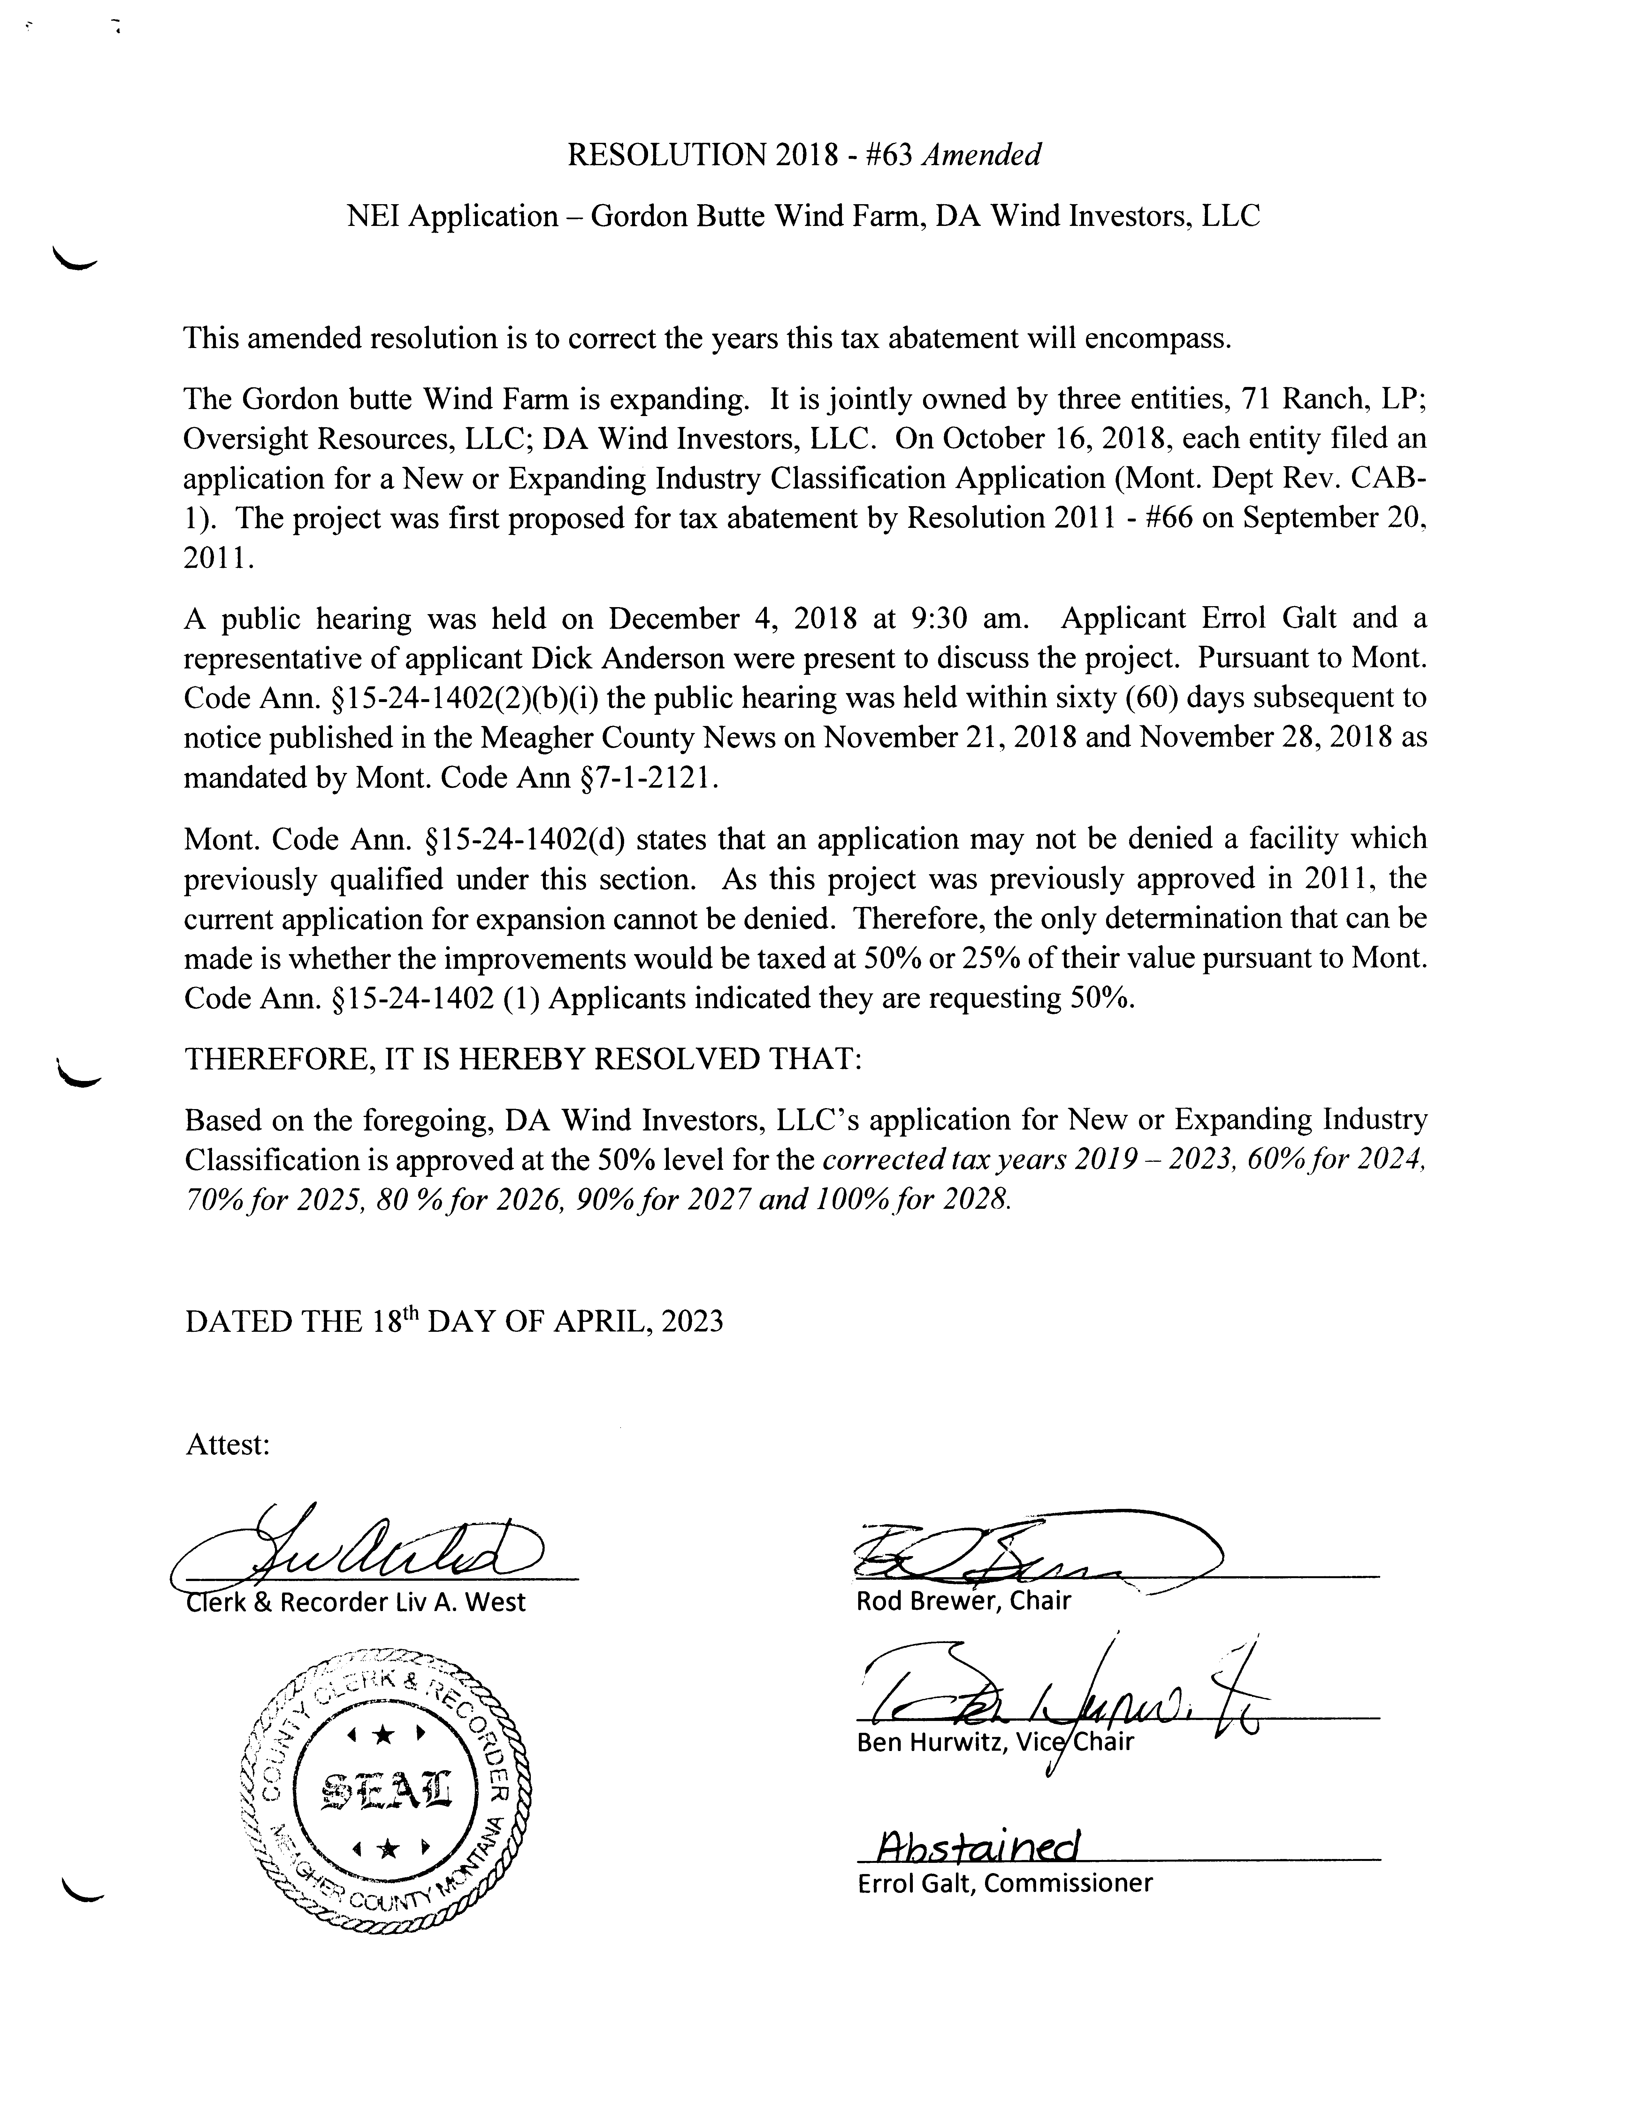

**Public Comment:**

No Public Comment.

**Claims Approved:**

Commissioners were presented with Check #60242 through Check #60257 totaling $37,763.43. All Checks were signed as presented.

**Meeting Adjourned:**

Meeting was adjourned at 4:00 p.m.

**Next Meeting:**

Commissioners are scheduled to meet Tuesday, May 2nd, 2023.

**CLERK & RECORDER CHAIRMAN**

**SEAL VICE-CHAIRMAN**

**COMMISSIONER**

Note: Minutes taken by Clerk to the Commission Rebekah Luchterhand

Distributed May 2nd, 2023 to Chairman Brewer, Vice Chair Hurwitz, and Commissioner Galt, and Clerk & Recorder West.