PROCEEDINGS OF THE BOARD OF THE COMMISSIONERS
MEAGHER COUNTY, MONTANA

Tuesday
August 8th, 2023
8:00 a.m. – 1:20 p.m.
Met in Commissioner’s Chambers

Meeting Called to Order:

Chair Brewer called the meeting to order at 8:00 a.m.

Commissioners Present:

Chair Rod Brewer, Vice-Charmain Ben Hurwitz were present for the meeting.

Claims Review / Minutes Review:

ACTION #1

Commissioner Brewer moved to approve the minutes from August 1st, 2023. Commissioner Hurwitz seconded the motion. A vote was taken and minutes were approved.

Airport Update – RPA – Lance Bowser:
Robert Peccia & Associates (RPA) Engineer, Lance Bowser, Airport Board Member Sam Berg and Airport Board President Kurt Burns entered the chambers at 8:20 a.m.

Bowser opened the meeting by reviewing recent improvements to the airport. The FAA grant AIP 3-30-0083-012-2021is complete. The crack sealing, seal coating, coal tar and painting is 100% completed and the closeout documents have been submitted. The Airport Layout Plan was submitted to the FAA on 3/08/23 and was approved by FAA on 06/06/23. The FAA Grant Closeout Final Report was submitted on 06/16/23 and we are waiting for the FAA to close the grant and reimburse the county the 10% hold back of $9,183.48.

Bowser then reported on the FAA Grant AIP 3-30-0083-013-2024 Obstruction removal grant. Instrument Approach Procedure Data Collection was completed on 11/28/22. FAA Flight Procedures were able to design a vertically guided approach with obstructions in place. The GPS instrument approach procedure development could still fail at flight check prior to publication. The Instrument Approach check is scheduled for this fall. The Instrument Approach procedure is scheduled for publication on 7/11/24 subject to flight check this fall. Bowsers recommended waiting on the obstruction removal grant until flight check is complete.

Bowser reported that the AWOS upgrades are complete, the next option for the AWOS system would be to add the National Airspace Data Interchange Network (NADIN). The addition would cost an estimated $50 / month.

Bowser reviewed the Non- Primary Entitlement Transfer Agreement with the Havre Airport. Havre has one final payment of $155,000 due in 2024 and the agreement will be fulfilled.

Bowser gave an update on Capital Improvement Plans (CIP) for the airport. The plan is updated annually to justify annual FAA funding accumulations of Non-Primary Entitlement (NPE) and Bipartisan Infrastructure Law (BIL) funding and to help the FAA and Airport align funding for major projects.

The Airport Board is considering strengthening the runway. Adding 2 ½ inches to the current runway would possibly allow the airport to accommodate aircraft up to 45,000 pounds, such as, Net Jets aircraft. The FAA has additional funding for strengthening the runways and taxiways available until 2025. Engineering for this project would need to start in 2024 to be completed and ready for construction in 2025. Bowser will look into how much the overlay would increase the weight capacity on the runway and report back next week.

Bowser discussed the installation of 3-4 Helipads along with 4-5 turf pads in the North West portion of the airport. The pads would be approximately 60x60, big enough to accommodate Chinook Helicopters. The area is currently designated in a Land Use Agreement with the United States Forest Service; however, the LUA is only when the USFS is actively using the area and will be available to the public any other time. This project would have the standard FAA 10% match. Burns stated he will pursue options for the match.

Bowser also discussed a land acquisition (easement) needed if the instrument approach passes the flight check this fall. The land acquisition for the main runway includes widening the easement on the North of the airport and acquiring less than ½ an acre on the Southwest side of the airport. Acquisition for the turf runway include an area to the east of the airport that is mainly highway right of way and an area on the East side of the airport on State of Montana land. The easements are in place to prevent homes, large buildings, grain silos, etc. from being constructed in what could potentially be a “crash area.”

Bowser reported that he had received correspondence from Mercy flight regarding the number of missed flights due to unknown weather conditions on the ground. Bowser discussed the opportunity to install weather cameras at the airport. The system would cost $9000 for 3-4 cameras. The cameras would catch roughly 30% of ground conditions and 70% of sky conditions. The Montana Department of Transportation would pay 50% outright and is eligible for a grant from Montana Aeronautics for the other 50%. The cameras would be installed by Montana Aeronautics staff. The Airport Board and the Commission decided to move forward with the Weather Camera Installation.

The Final CIP is tabled until August 15th 2023 at 1:30 p.m.

ACTION #2
Resolution FY 23.24 #7

Commissioner Hurwitz moved to approve the Weather Camera project with 50% funding from the State of Montana Department of Transportation and applying for a Montana Aeronautics grant. If the grant is not approved the project will not move forward. Commissioner Brewer seconded the motion. A vote was taken. The matter is hereby resolved.

Arrowhead Meadows Golf Course - Cal Moore:
Arrowhead Meadows Treasurer Cal Moore and Board President Bill Cummins entered the chambers at 9:20 a.m.

Moore opened by presenting the Commission with a Power Point Presentation of the economic and aesthetic treasures of Meagher County and the importance of investing in our future. Moore stated that Arrowhead Meadows is an aesthetic treasure to the community and is one of the first things you see as you come into town. Moore discussed the budget for Arrowhead Meadows Golf Course (AMGC) stating that for the current 2023 season approximately 53% of the golf courses expenditures are wages, followed by 10% is for electricity / irrigation, 3.65% is repairs and maintenance, 9.5% is course improvement and enhancement and miscellaneous costs make up the remainder of their budget. Moore further reported that course revenue for the current season comes from 20% memberships, 25% Green fees, 25% tournaments, and the remainder is made up by fund raisers and donations. AMGC also participates in the Golf & Go program where a golfer can purchase a pass and golf at any of the 42 participating golf courses throughout the state of Montana. Moore presented the Commissioners with a list of capital improvements needed for the 2024 season including main irrigation, sprinkler heads, controls and a zero-turn mower. The sprinklers were installed in the mid-80s and are starting to fail. The zero-turn mower is no longer functioning and Moore has been using his personal mower this season. Moore requested $10,000 from the county to help with the equipment replacements.

Commissioner Brewer stated they would consider the request; however, it will need to be approved in the Fiscal Year 23.24 budget.

Health Nurse Report Eva Kerr:
Community Health Nurse Eva Kerr entered the chambers at 10:15 a.m.

Kerr opened by presenting her monthly report for July / August. Kerr stated that kids are starting to come in for school vaccinations, there have been 6 in office vaccinations so far. Kerr stated the State of Montana does not want her contacting parents regarding their children’s vaccinations, they would prefer the school to reach out to parents. Kerr stated that she met with the newly hired Superintendent of Schools Justin Barnes and County Attorney Hurwitz to discuss expectations for each other and the process if a child should test positive for Covid or any other reportable illness.

Kerr participated in the Opioid meeting with other counties in the district. Kerr has trained the Sheriff, Deputies EMTs on administering Narcan. County officials and EMT are now carrying Narcan and can administer the anti-narcotic when there is a need.

Kerr stated that she and the County Sanitarian, Sean Hill looked into a restaurant complaint and she is continuing to monitor the Blue Green Algae at Bair Reservoir. The last test came back negative and the signs have been removed.

Kerr gave an update on Red Ants Pants (RAP) festival, stating that everything went pretty well. Kerr stated that her costs were approximately $1000 this year. Sanitarian Sean Hill unutilized the weekend to perform restaurant inspections in the county and RAP falls under his monthly contract.

Kerr stated the Active Assailant Drill recently held at the school was a success and was a great learning experience for everyone.

Kerr ended with informing the Commission on the conditions of her office at Mountainview Medical Center. She stated that her office has had water leaks for the last 7 years due to the positioning of the windsock on the roof. They have rearranged the furniture to ensure they would not incur damage if the roof leaks again.

Congressman Matt Rosendale, Rep. Randy Bogden:
Representative Randy Bogden entered the chambers at 10:30 a.m.

Bogden opened by asking the Commissioners what issues Meagher County is facing.
Commissioner Brewer stated workforce housing is one of the largest issues the County faces. Commissioner Hurwitz asked about the availability of funding for the Smith River Road and other road maintenance. In the summer months during float season there are approximately 250 cars per day that travel that road.
Commissioner Hurwitz stated that Montana Fish Wildlife and Parks is not interested in helping to maintain the road despite the majority of the traffic being from people coming to float the Smith River and launching at Camp Baker. Meagher County was denied a FLAP grant because the project was too small.

Bogden stated, a portion of the tax money from Recreational Marijuana sales was supposed to be used for county road maintenance but Governor Gainforte vetoed the bill and legislature was not able to overturn the veto.

Commissioner Hurwitz then asked Bogden about funding opportunities available for a Public Information Officer to help the County Attorney’s office.
Bogden replied, all the issues the Commissioners brought up are consistent with what he is hearing across the State.

Wipfli Introduction – Clayton Johnston:
Clayton Johnson entered the chambers at 10:45

Johnson started by introducing himself and presenting the Commission with a letter outlining the scope of the audit. Johnson went on to explain that this is a federal single audit. Further explaining that when there are over $750,000 in federal expenditures it will trigger a single audit. A single audit means all federal programs are audited by one auditor.

Johnson stated his audit team is responsible for testing the county’s accounting practices to the Generally Accepted Accounting Practices (GAAP) and the Montana Code Annotated (MCA) and issuing an opinion on the finances and internal controls in the county. Johnson stated the deadline for a Federal Single Audit to be completed is October 31, 2023.

County Attorney Report – Burt Hurwitz:
County Attorney Burt Hurwitz entered the chambers at 10:55 a.m.

County Attorney Burt Hurwitz presented his monthly report. Hurwitz updated the Commissioner on the ongoing Civil and Criminal matters in Meagher County.

Public Comment / Claims Approved
Beth Hunt entered the chambers at 11:45 a.m.

Beth Hunt from the Meagher County Senior Center came in with a concern regarding a gentleman that stopped by the Senior Center asking her for help. Hunt stated the man moved here 5 years ago and bought a house; he just received a letter from his mortgage company stating his payment almost doubled to over $800 because of property taxes. Hunt stated she contacted the office of Governor Gianforte and they stated it was not their problem and they didn’t have time to talk to her. Hunt expressed concern of the Senior populations ability to pay their taxes with such a high increase. The Commission acknowledged Hurts concerns.

Public Hearing Budget Amendment:
Finance Officer Dayna Ogle entered the chambers at 1:30 p.m.

Ogle presented the Commission with the Budget amendments for Fiscal Year 22.23
Commissioners made the following motions.

ACTION # 3
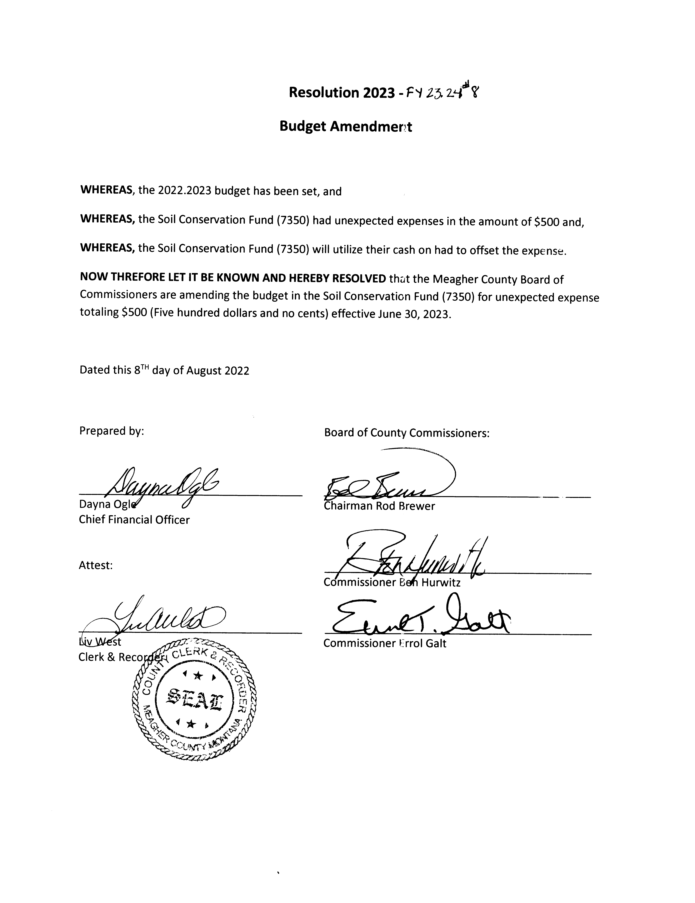
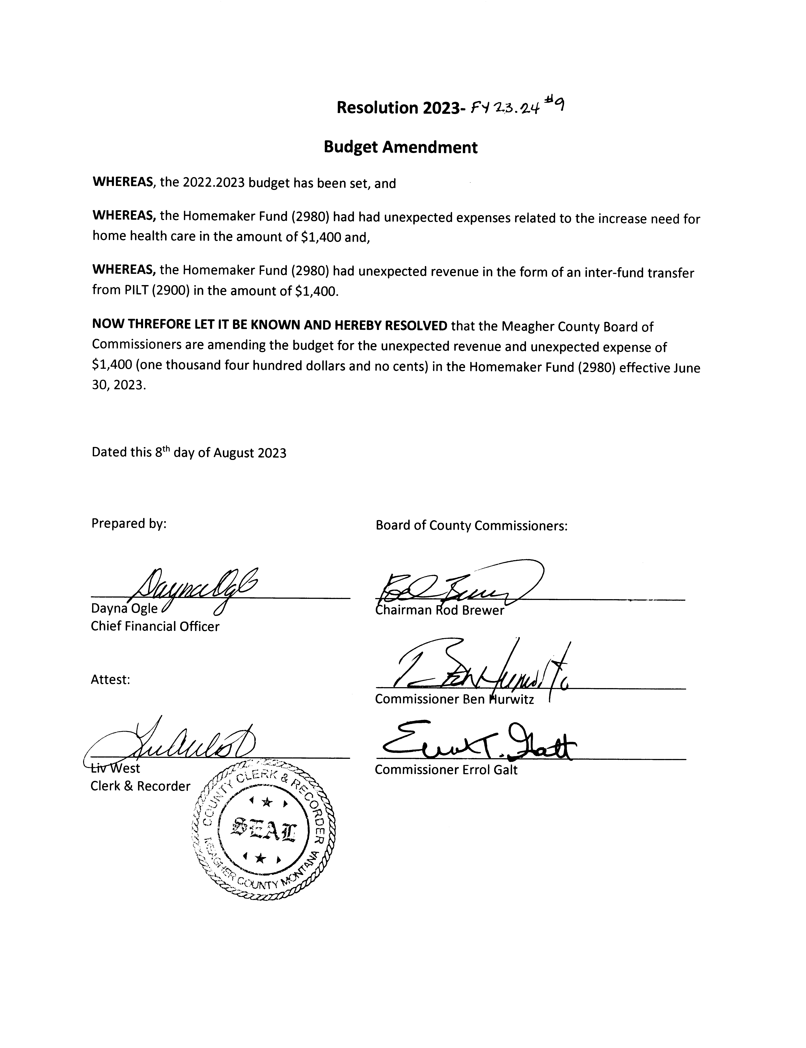

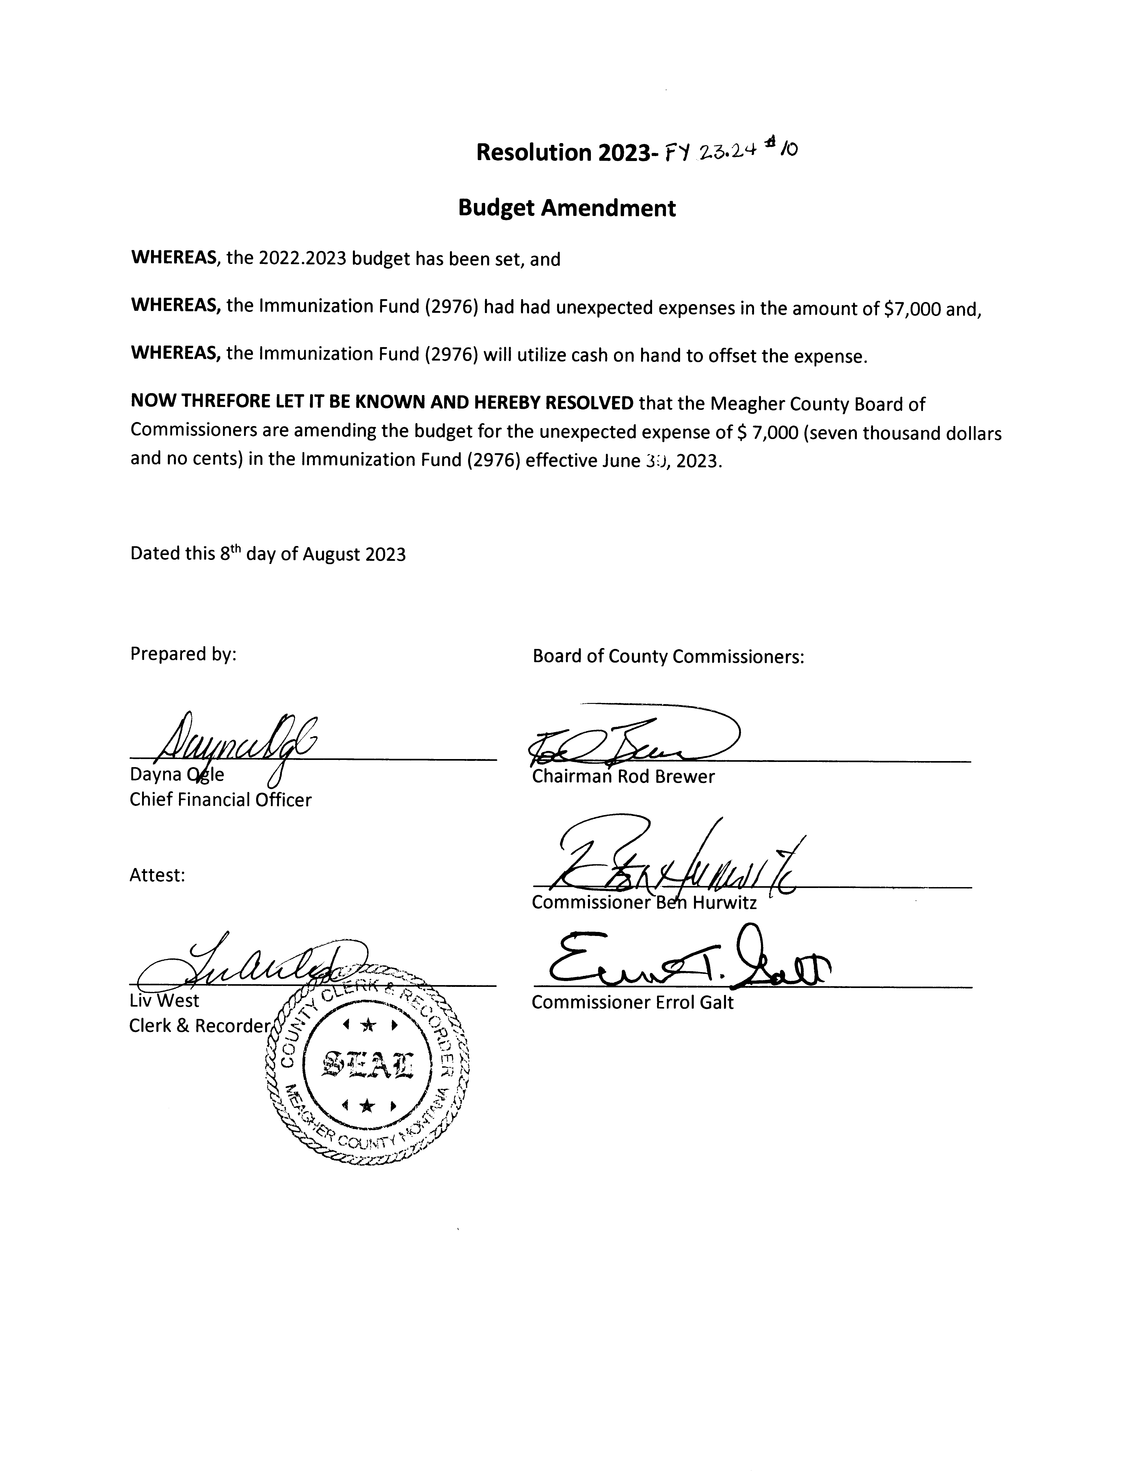
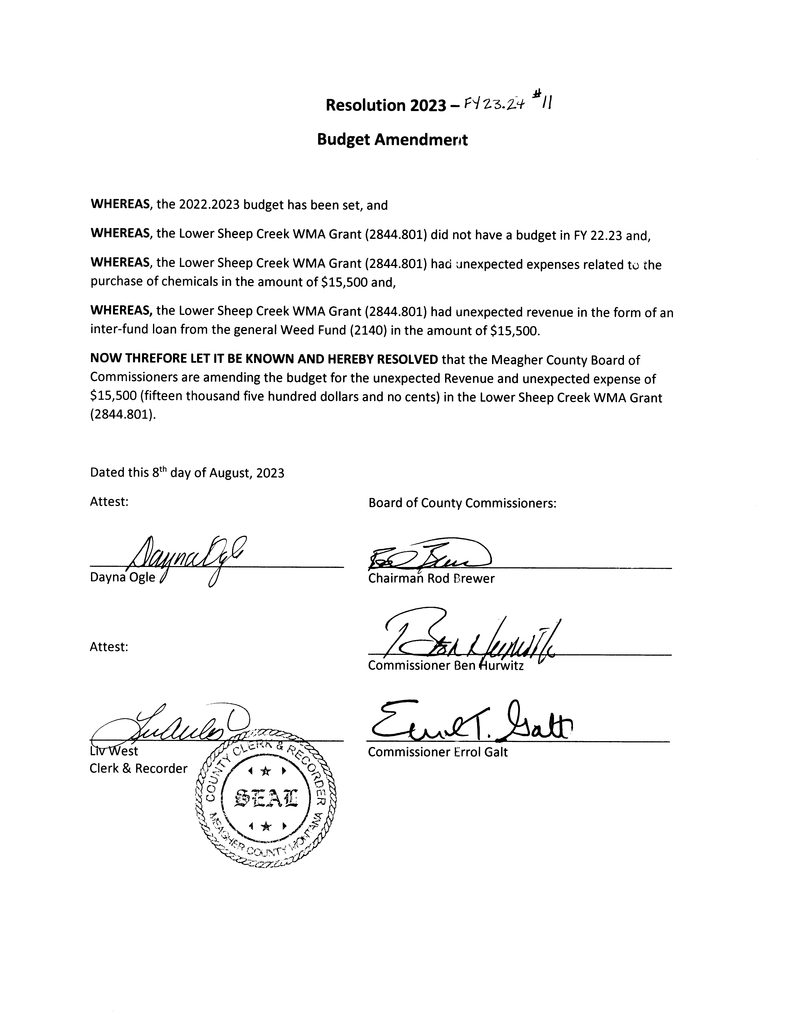
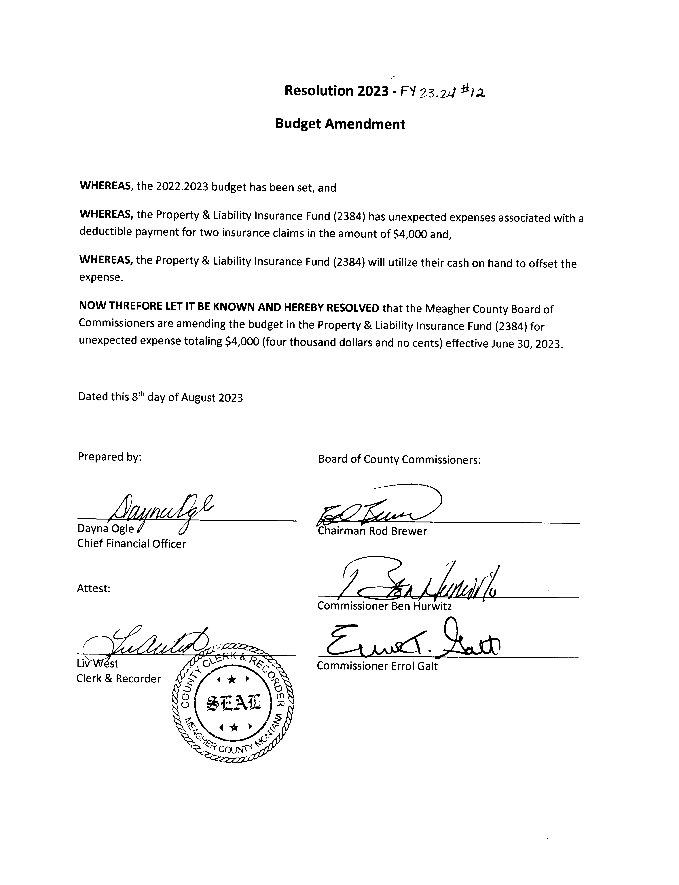

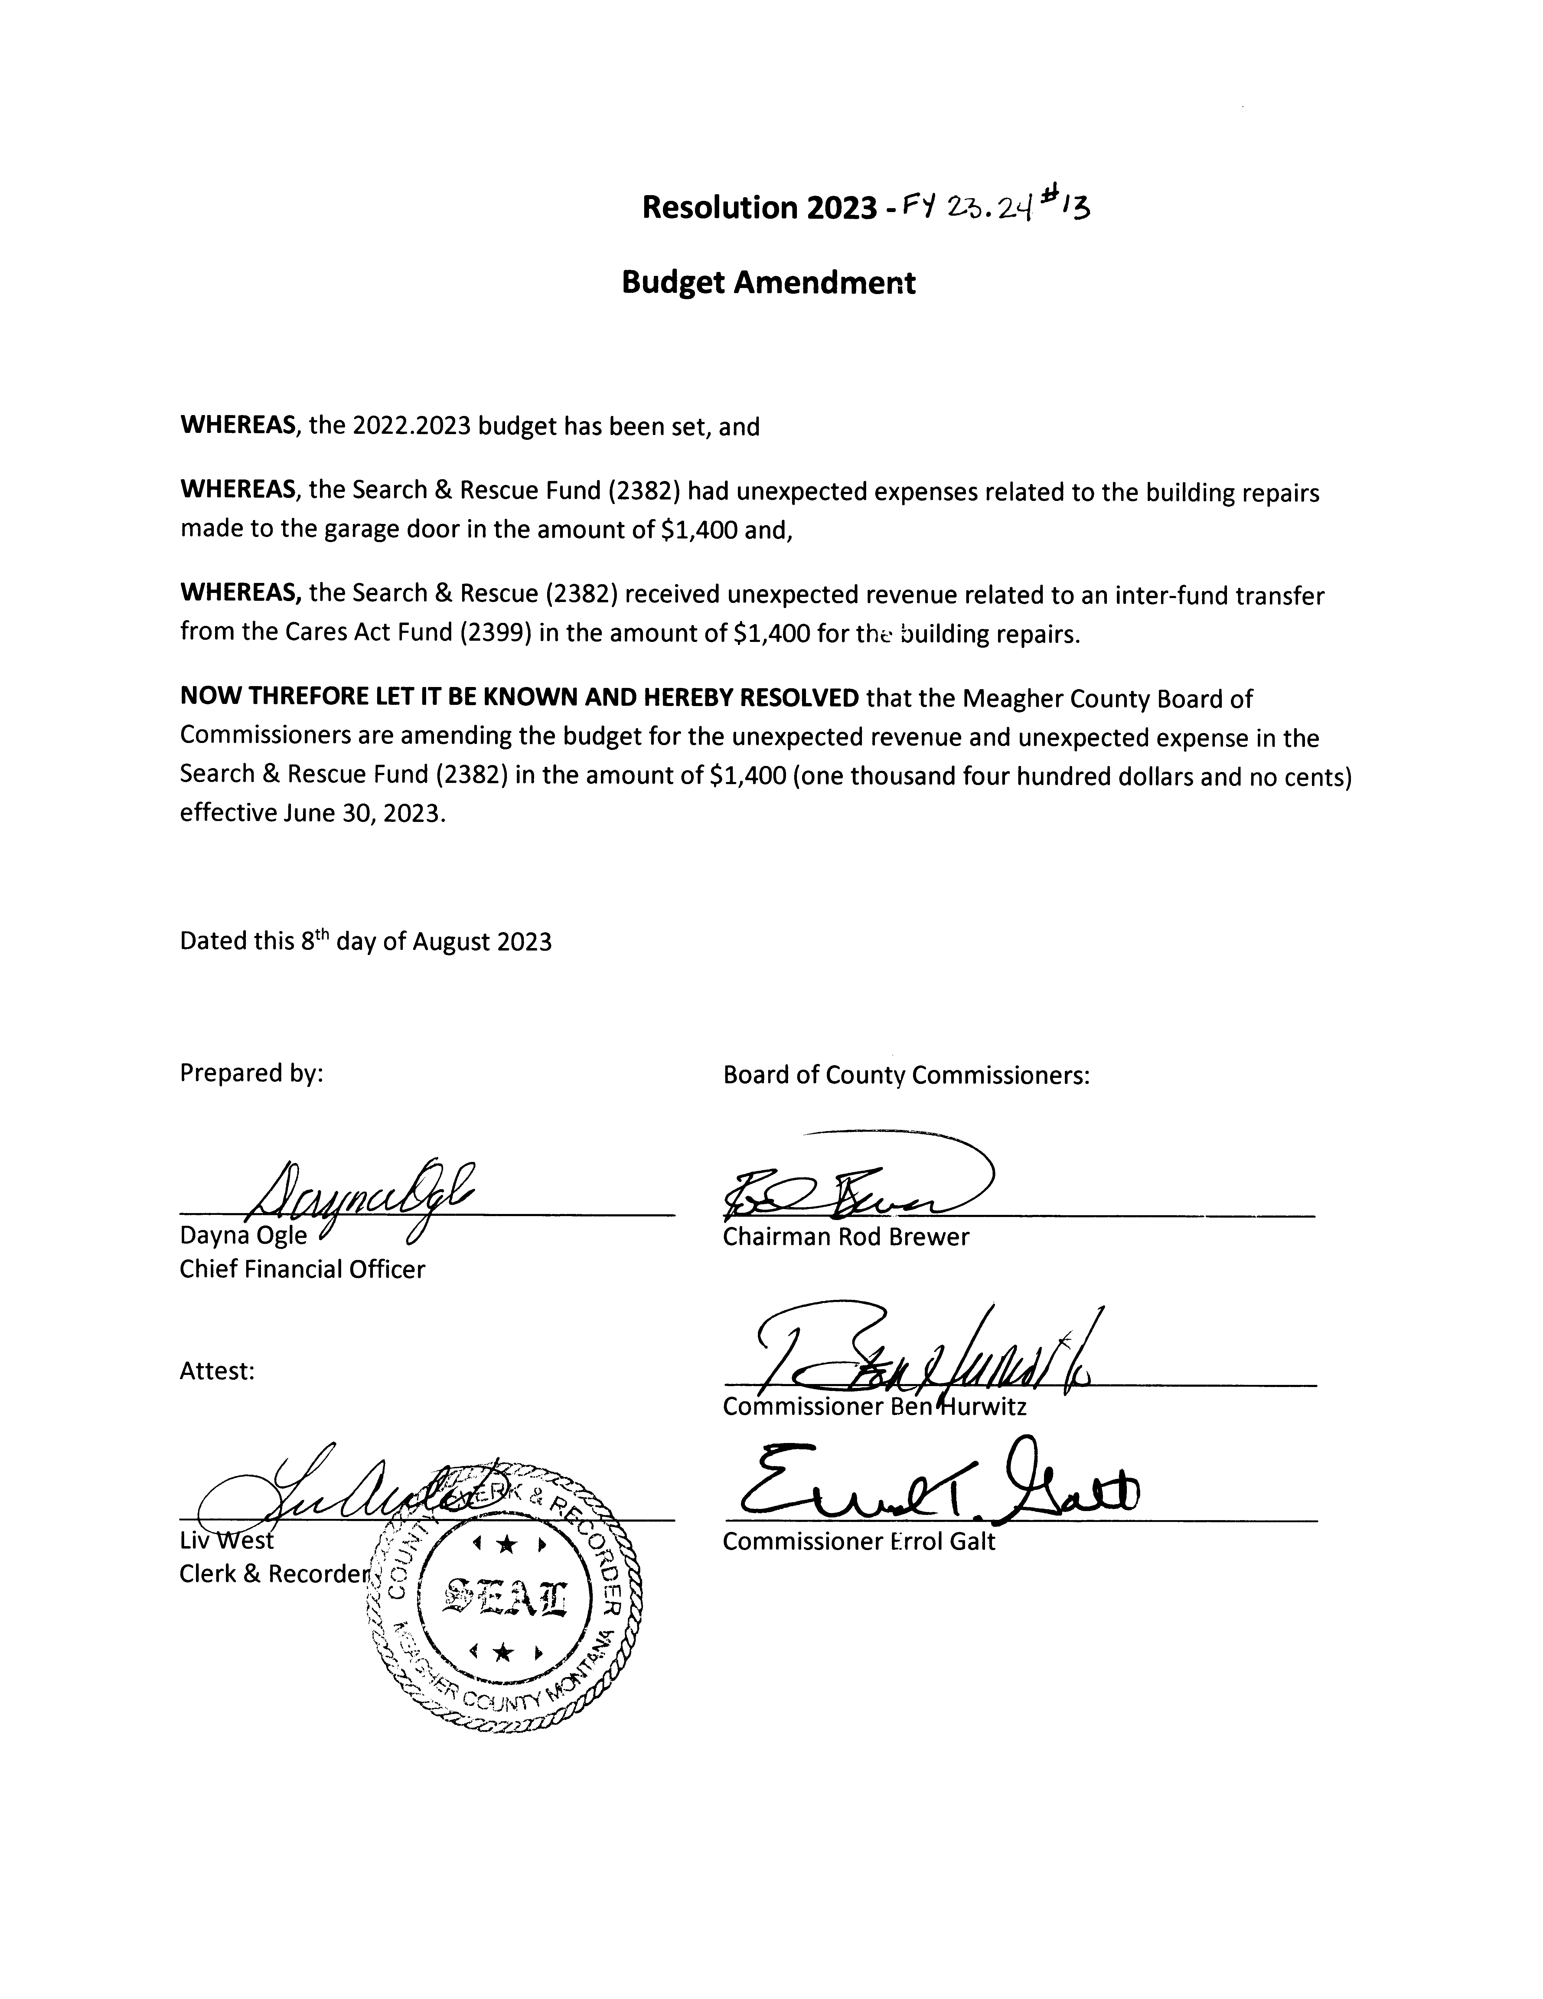
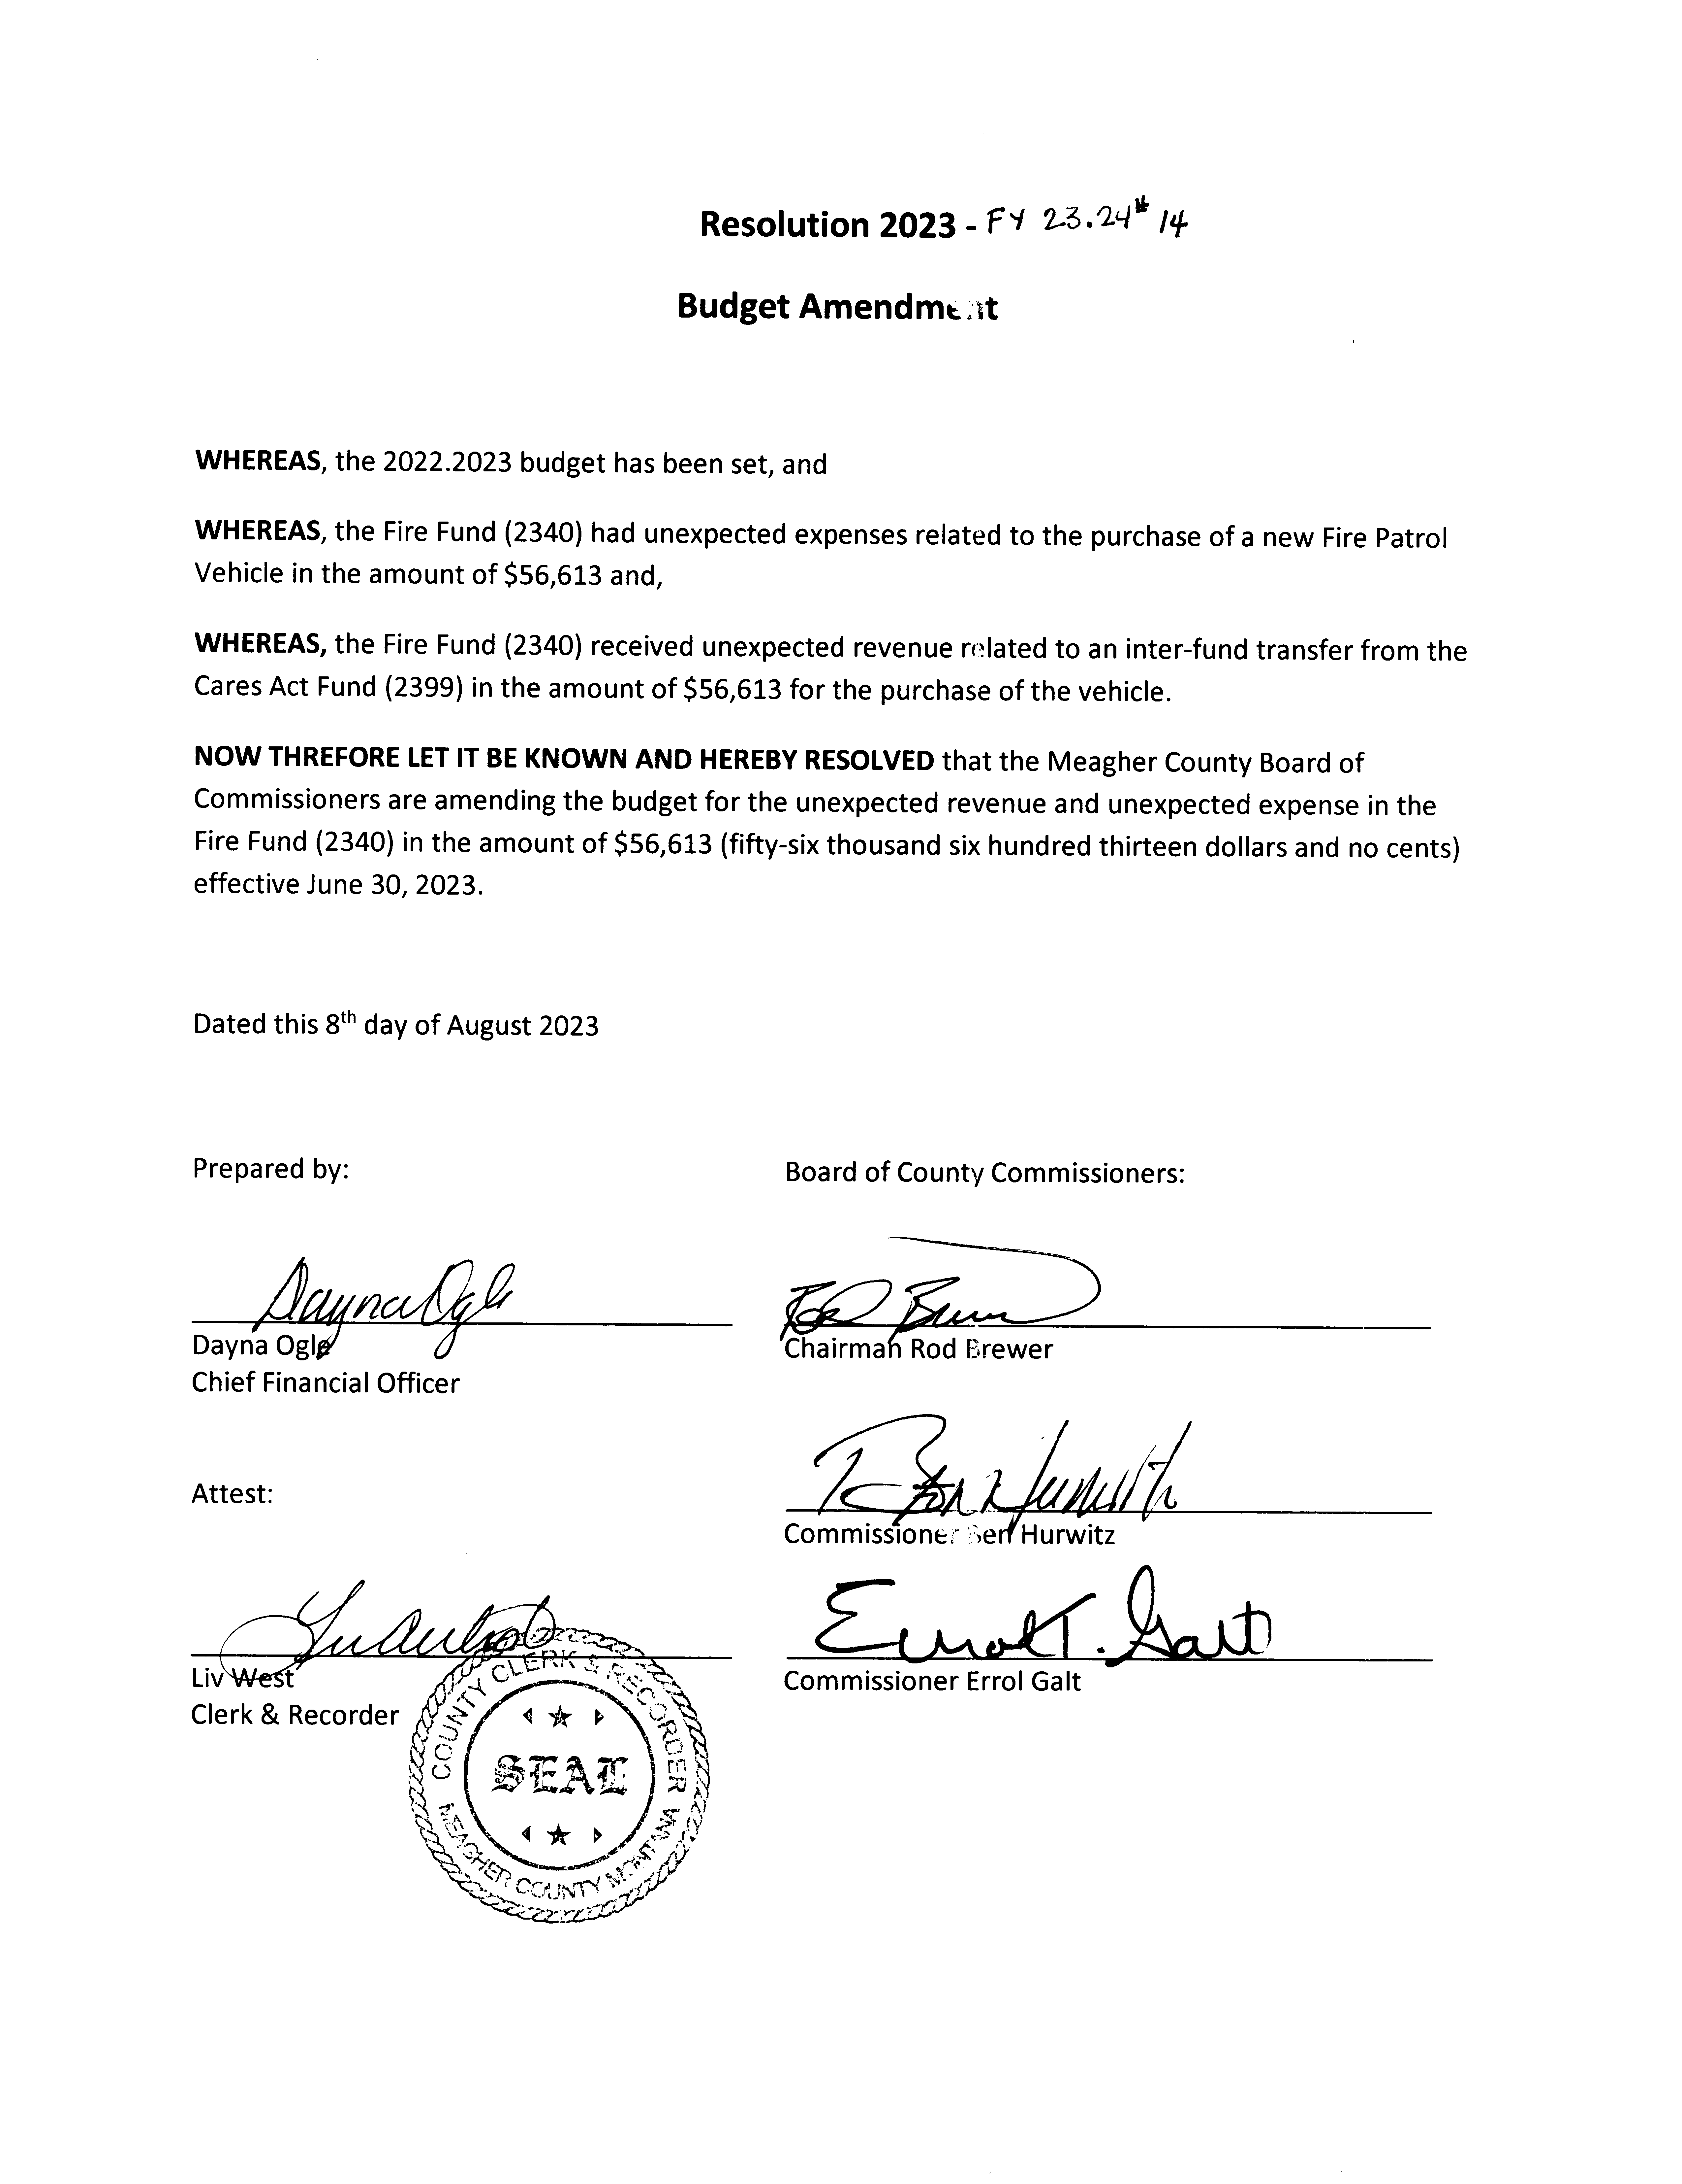

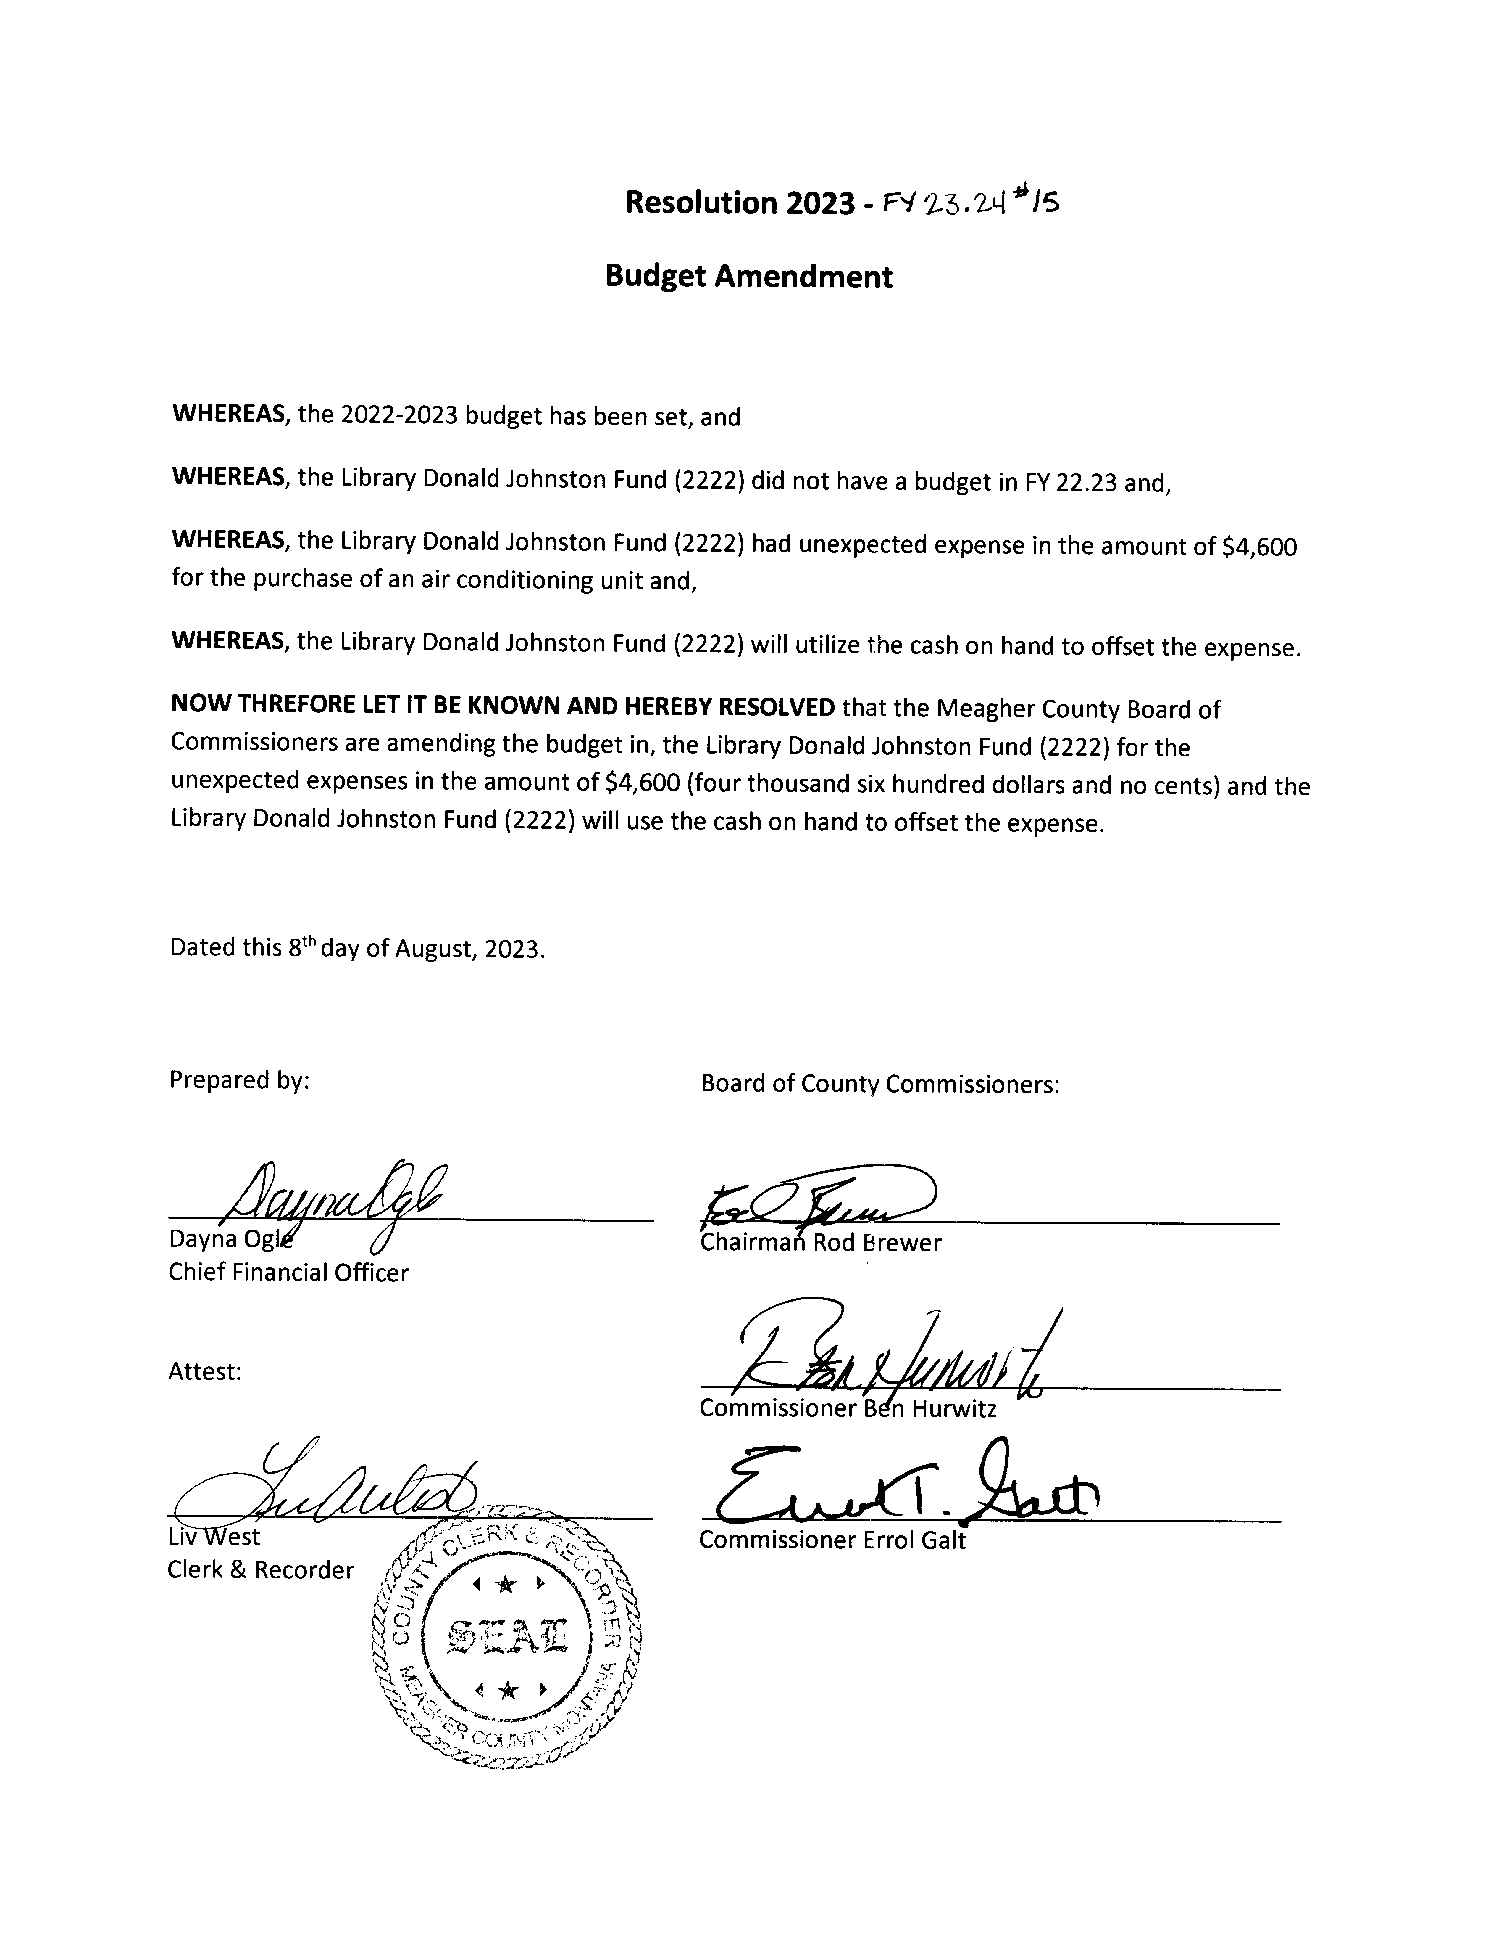
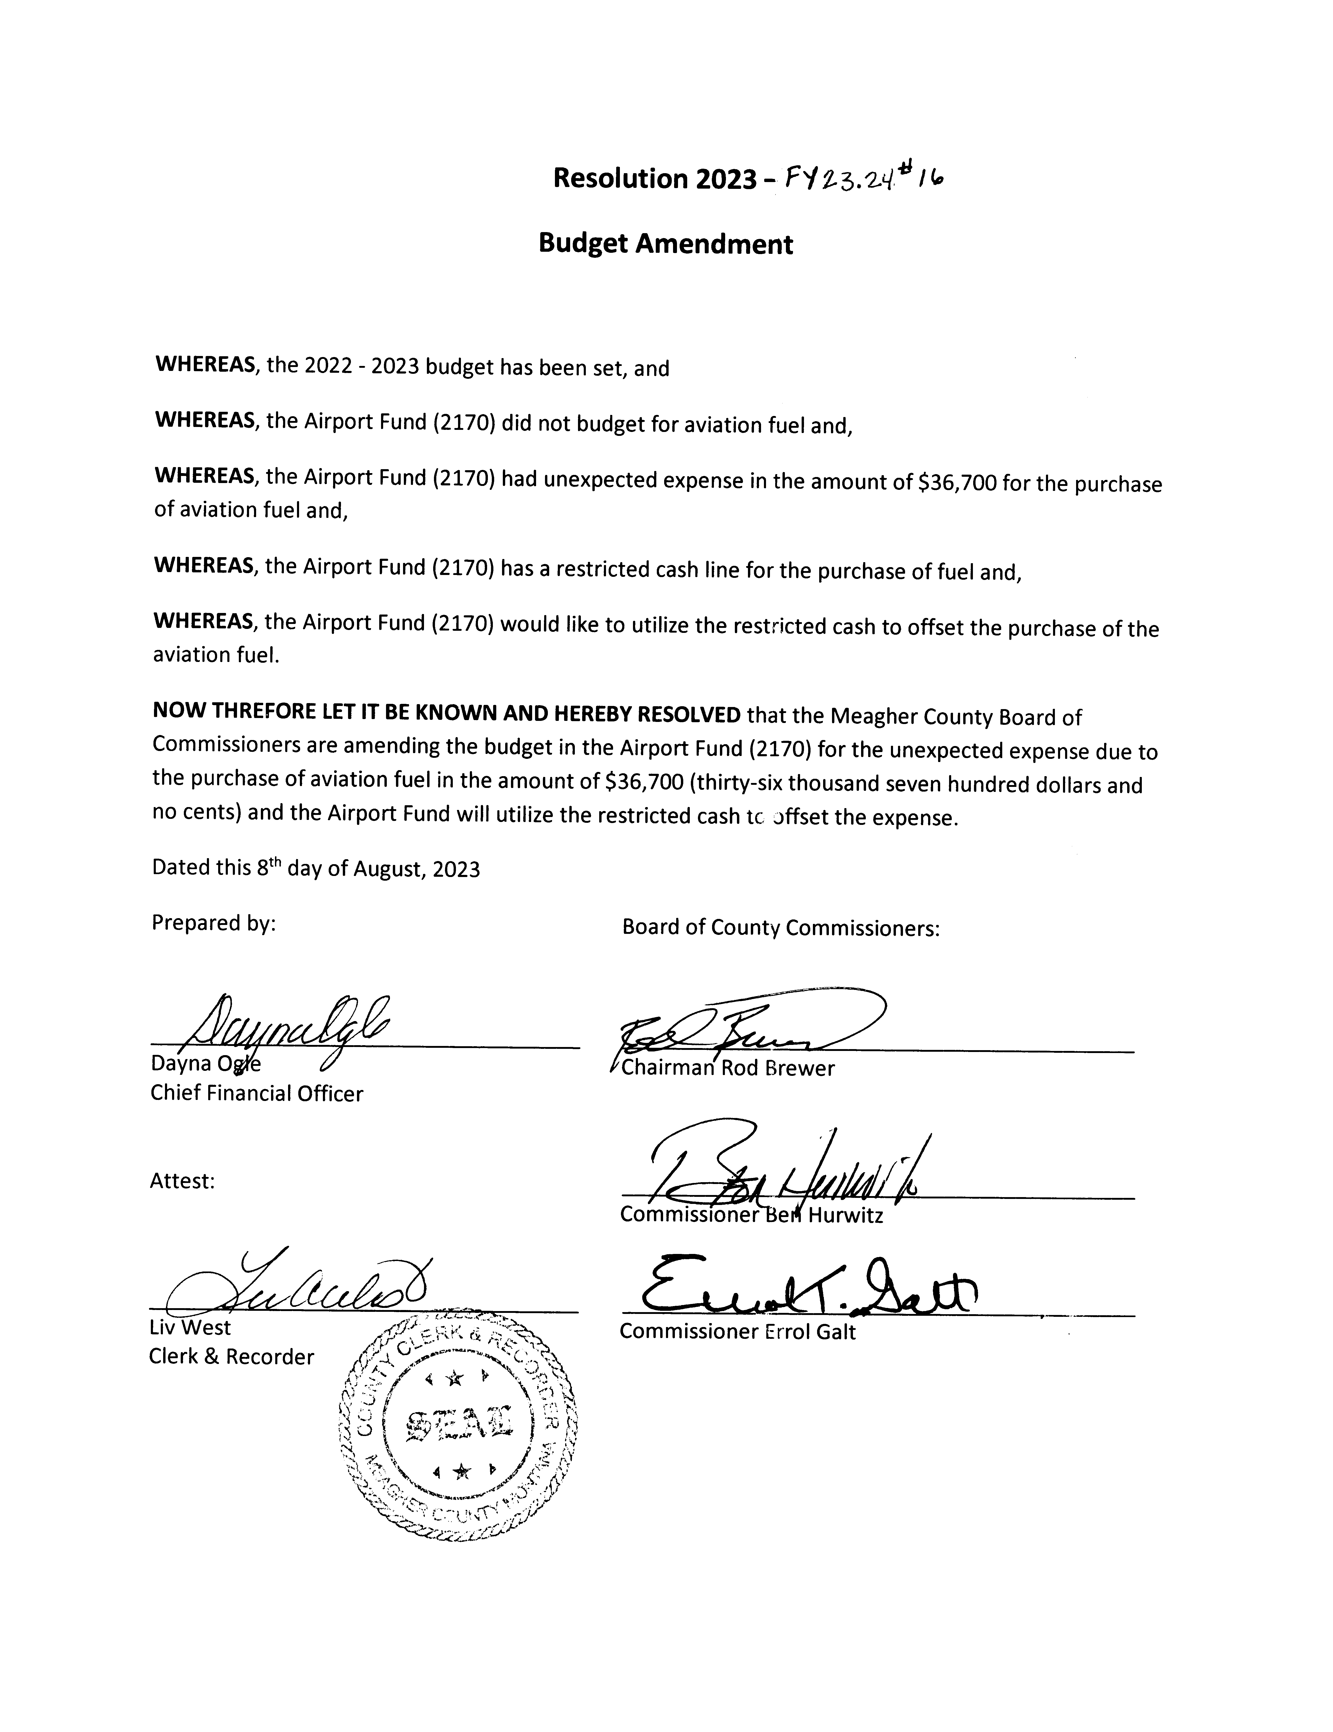

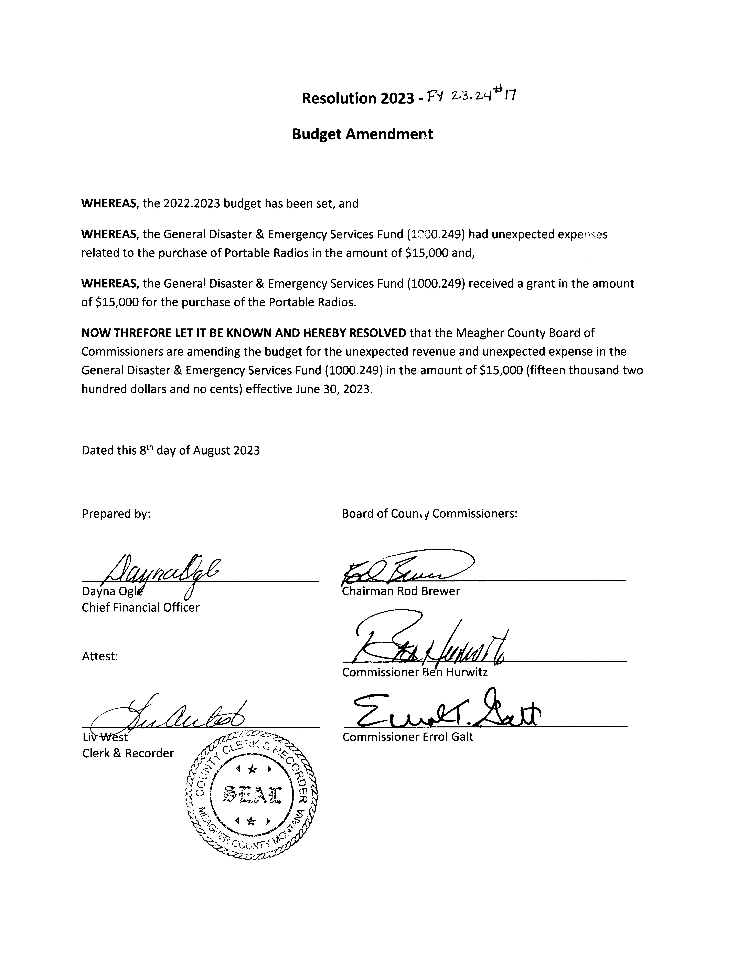

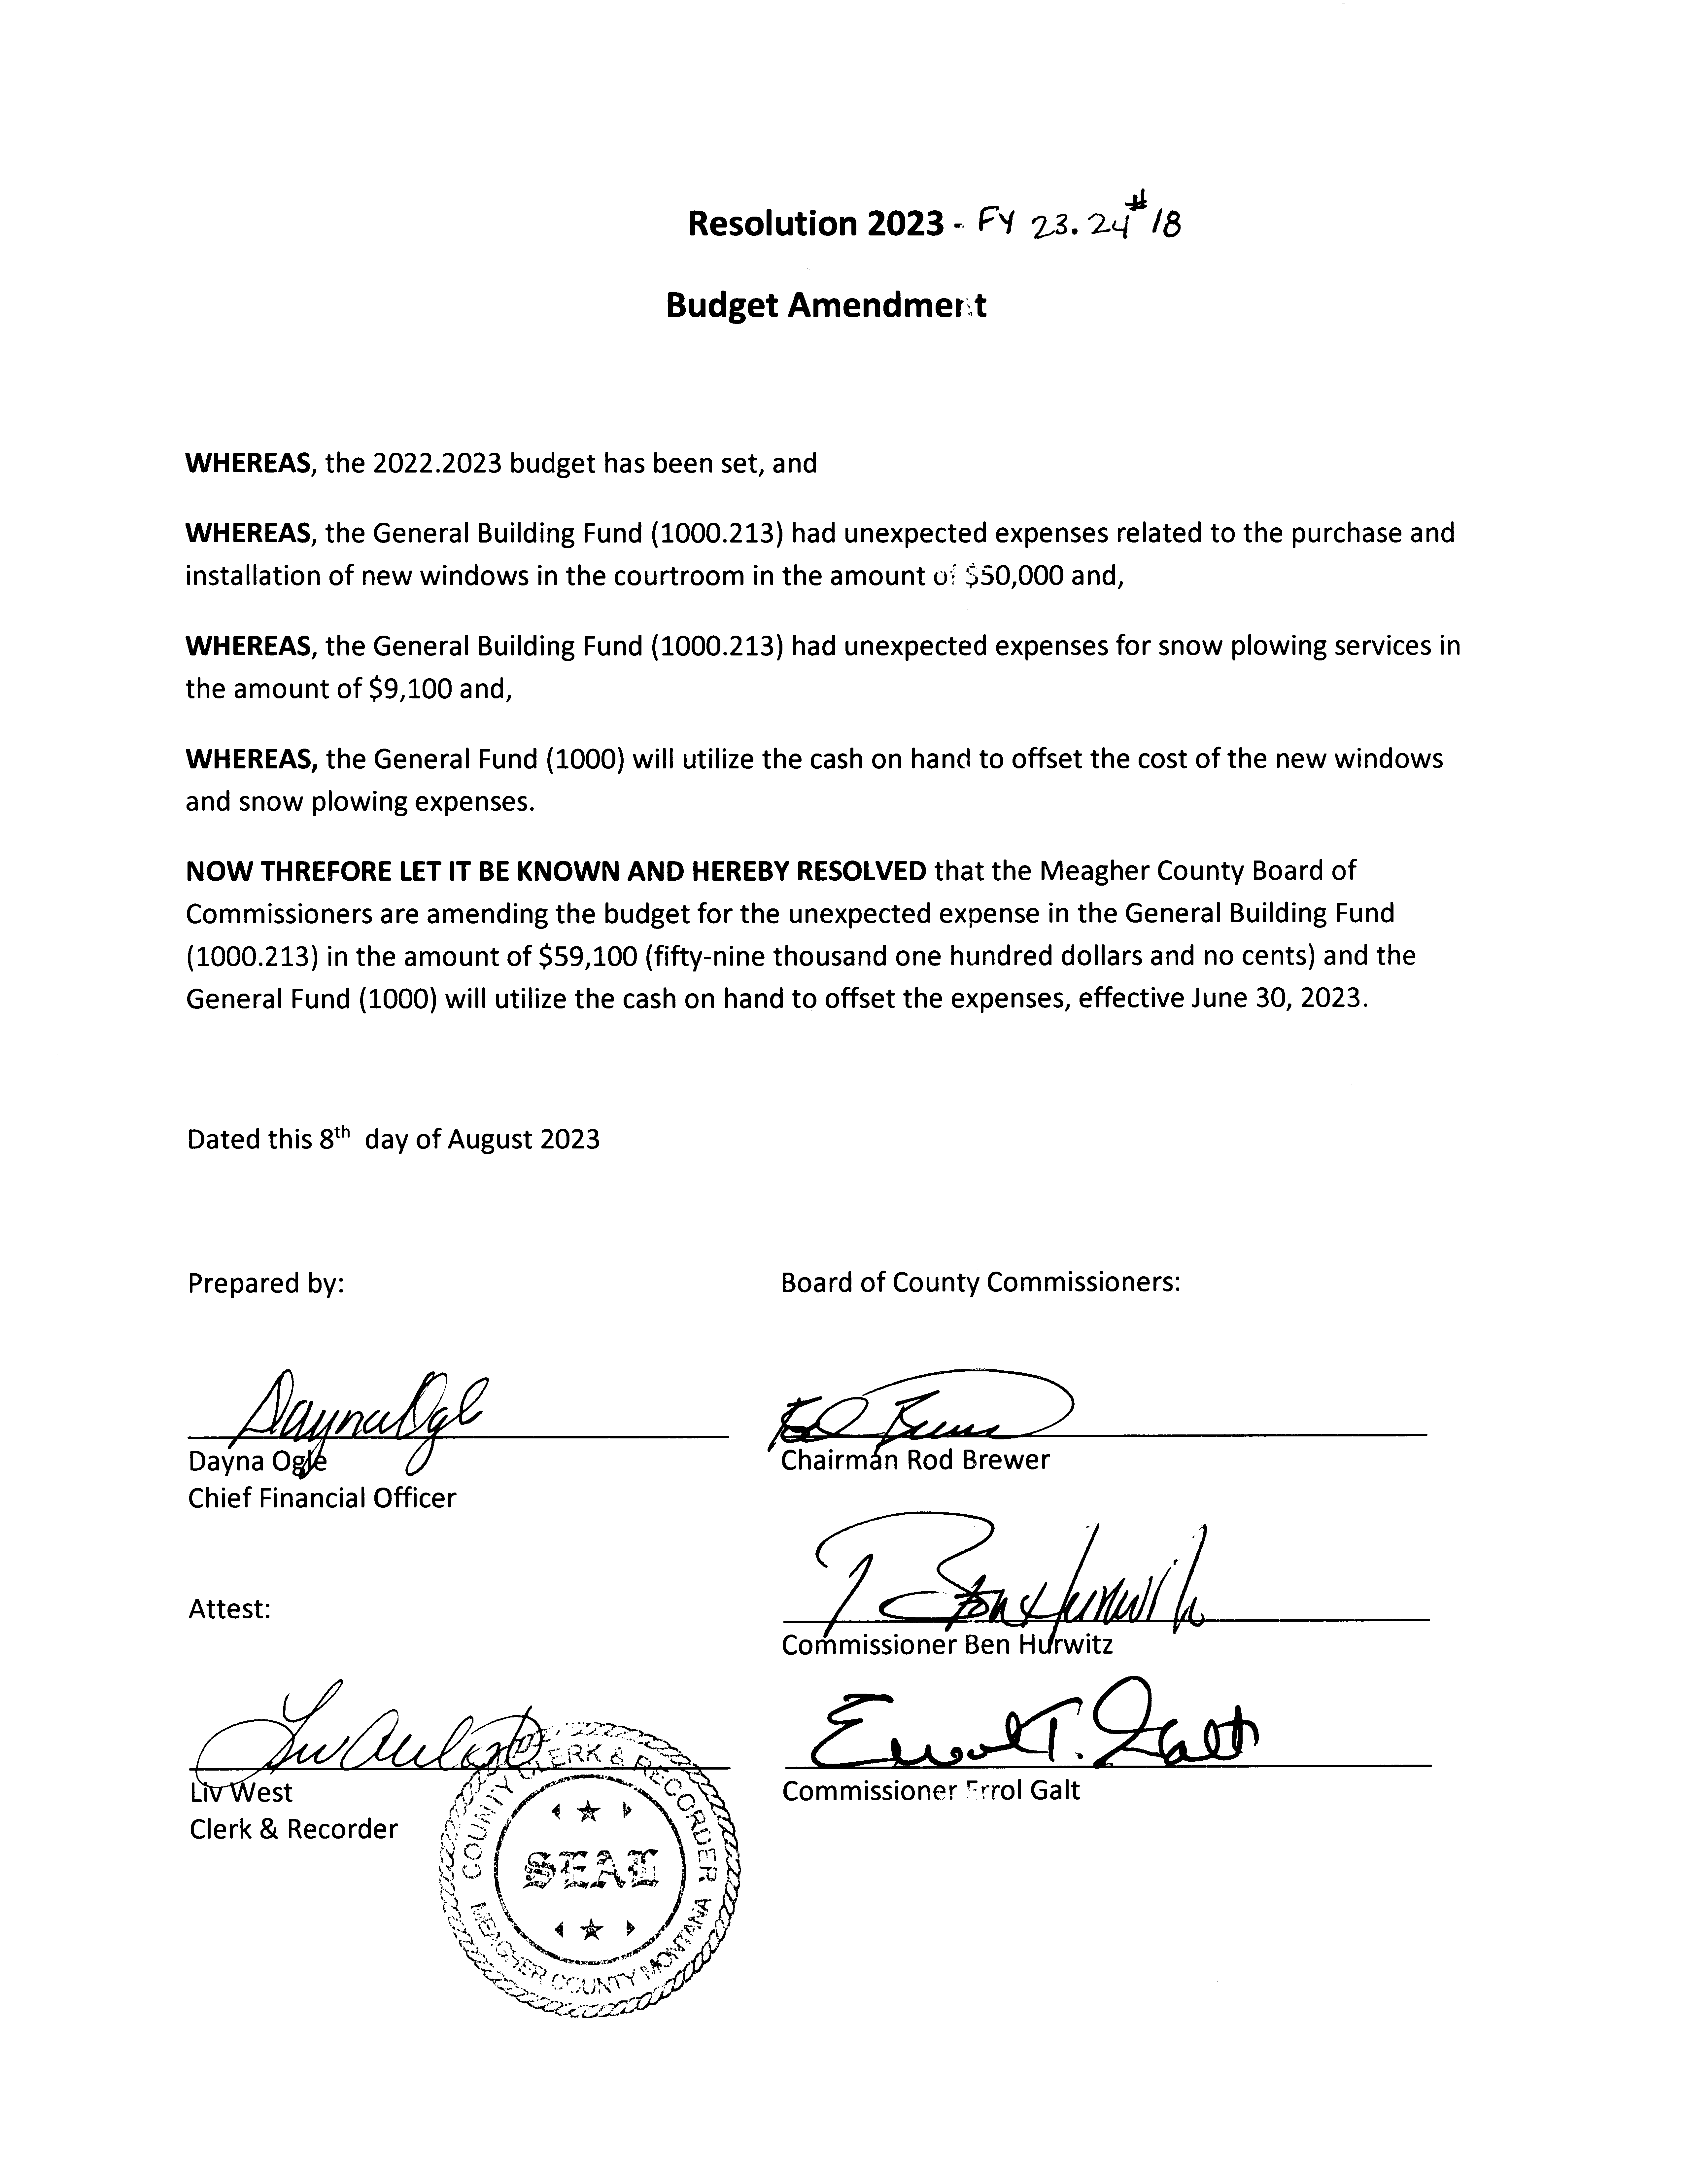
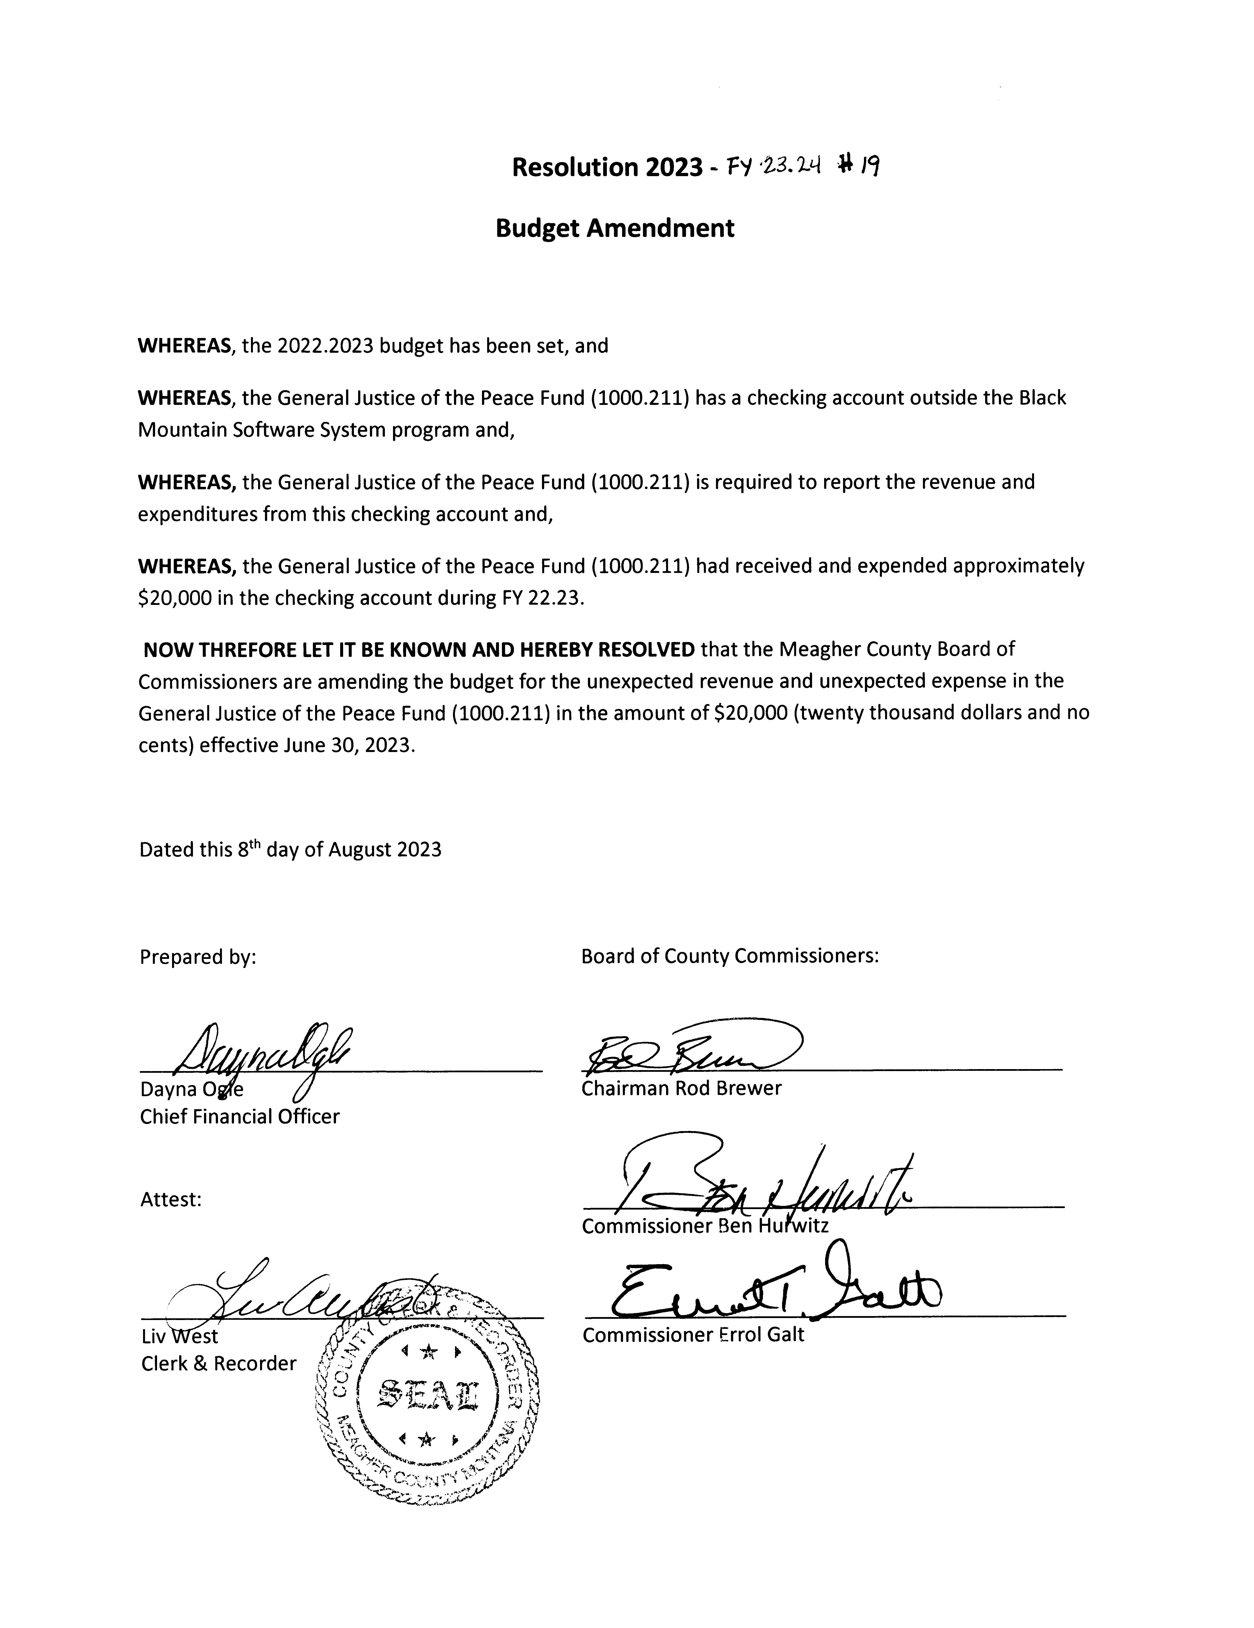
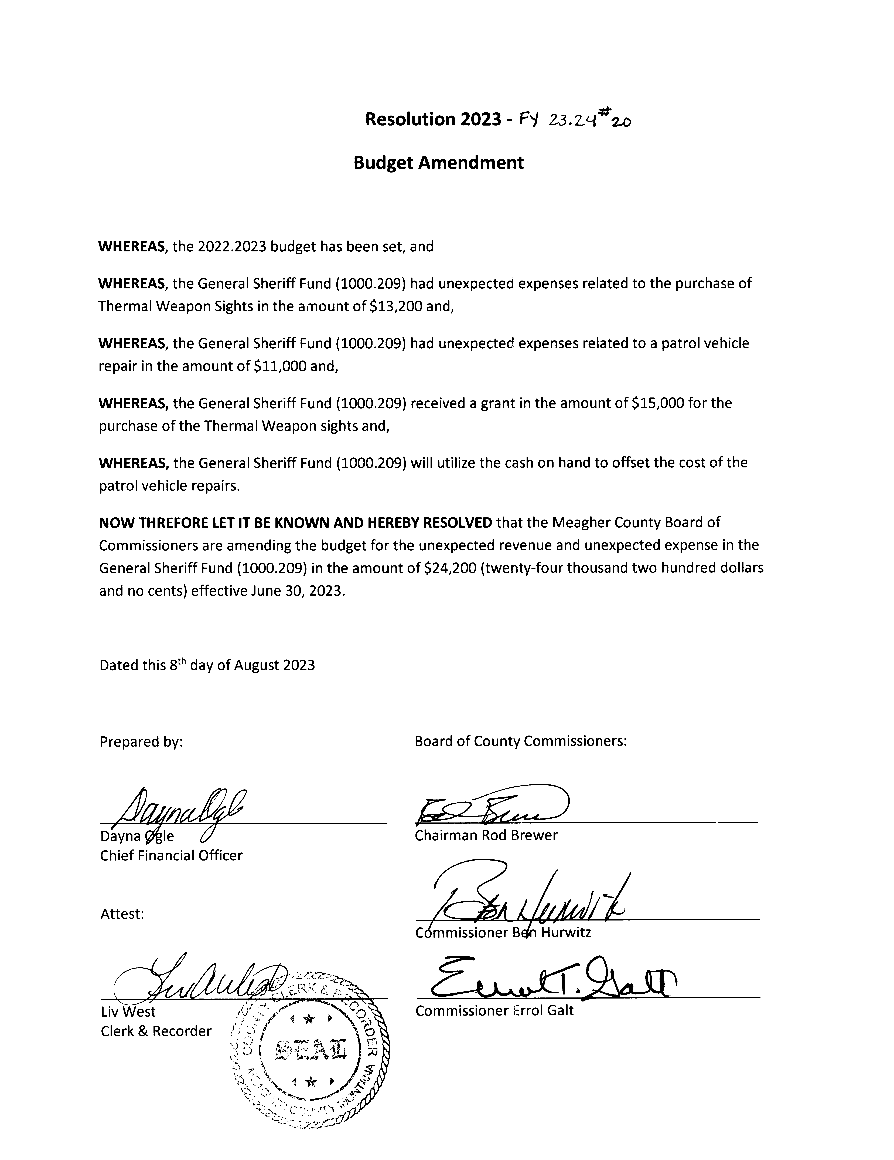
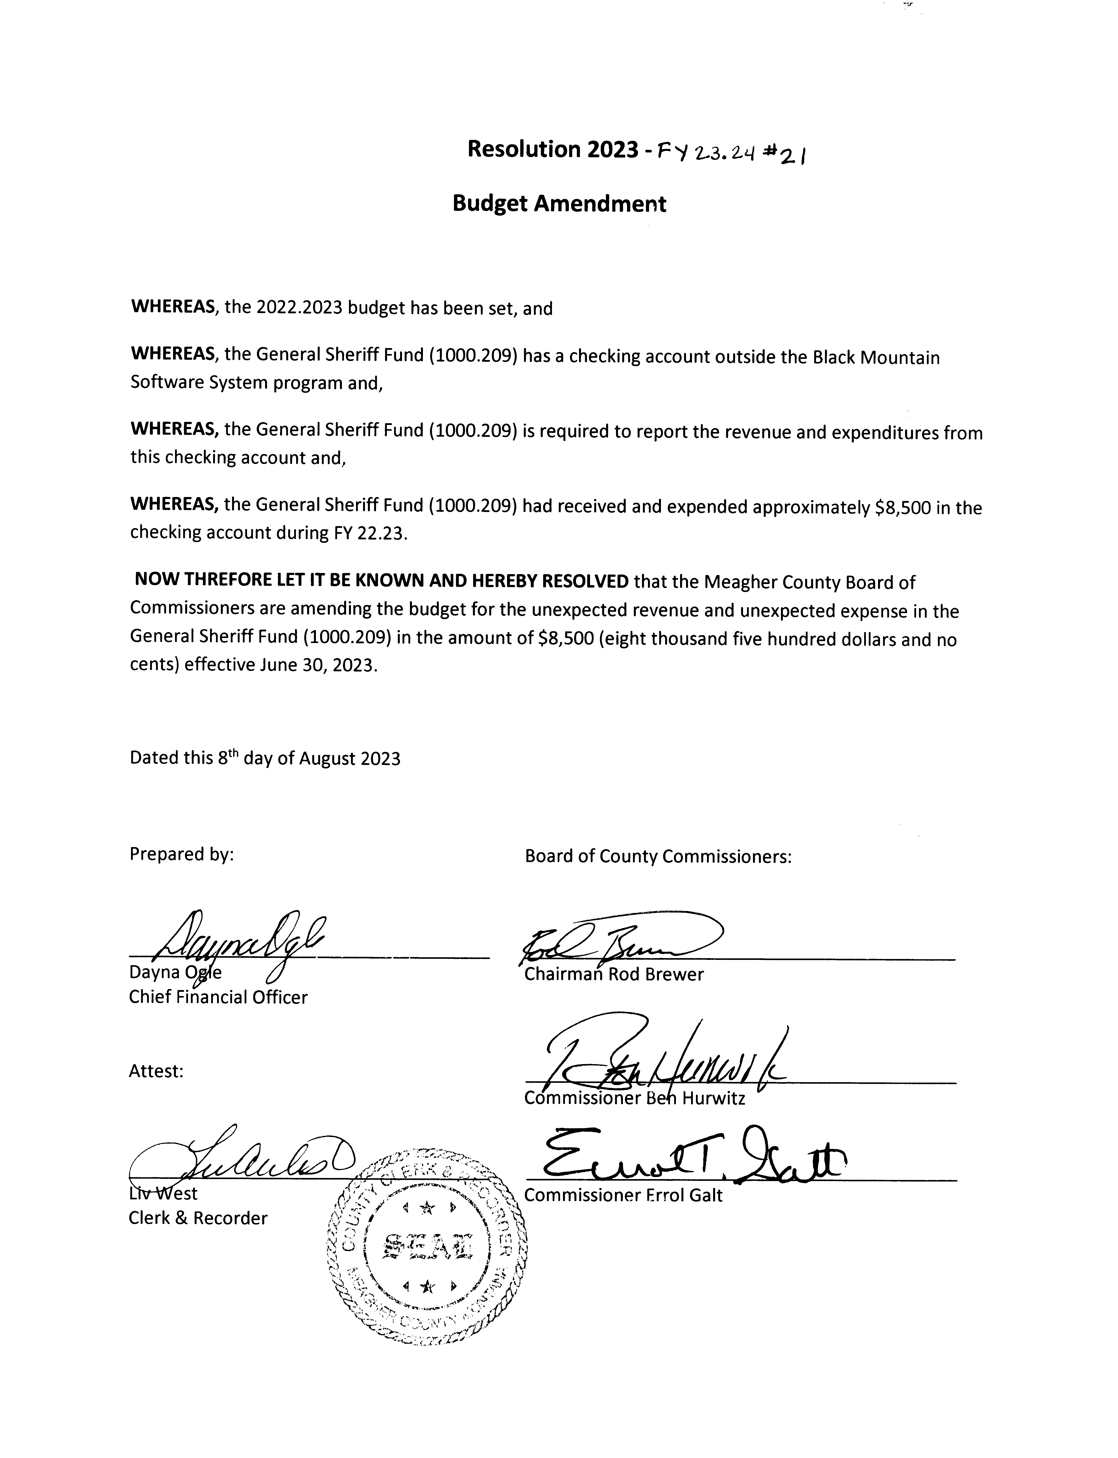

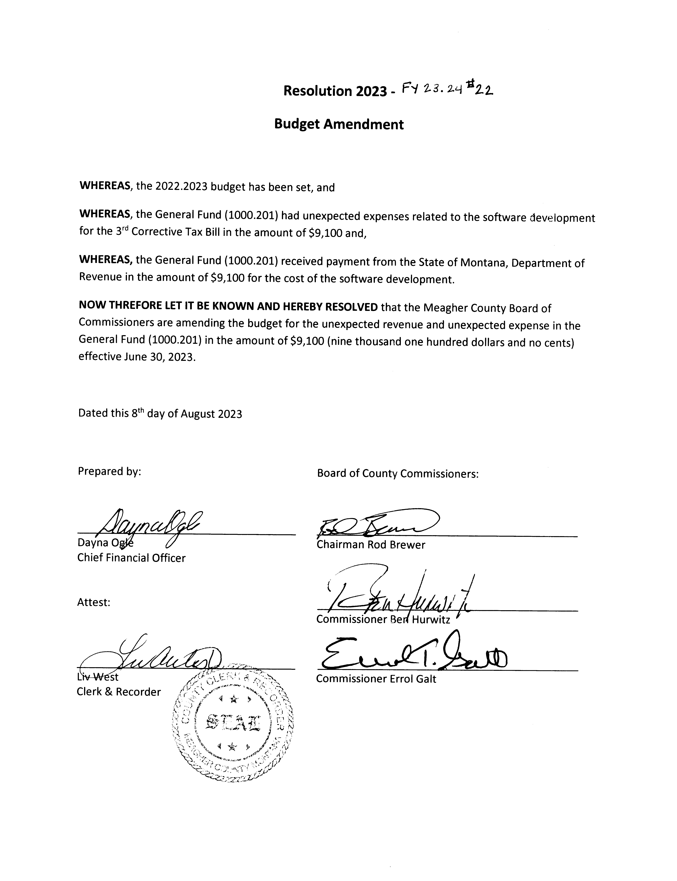

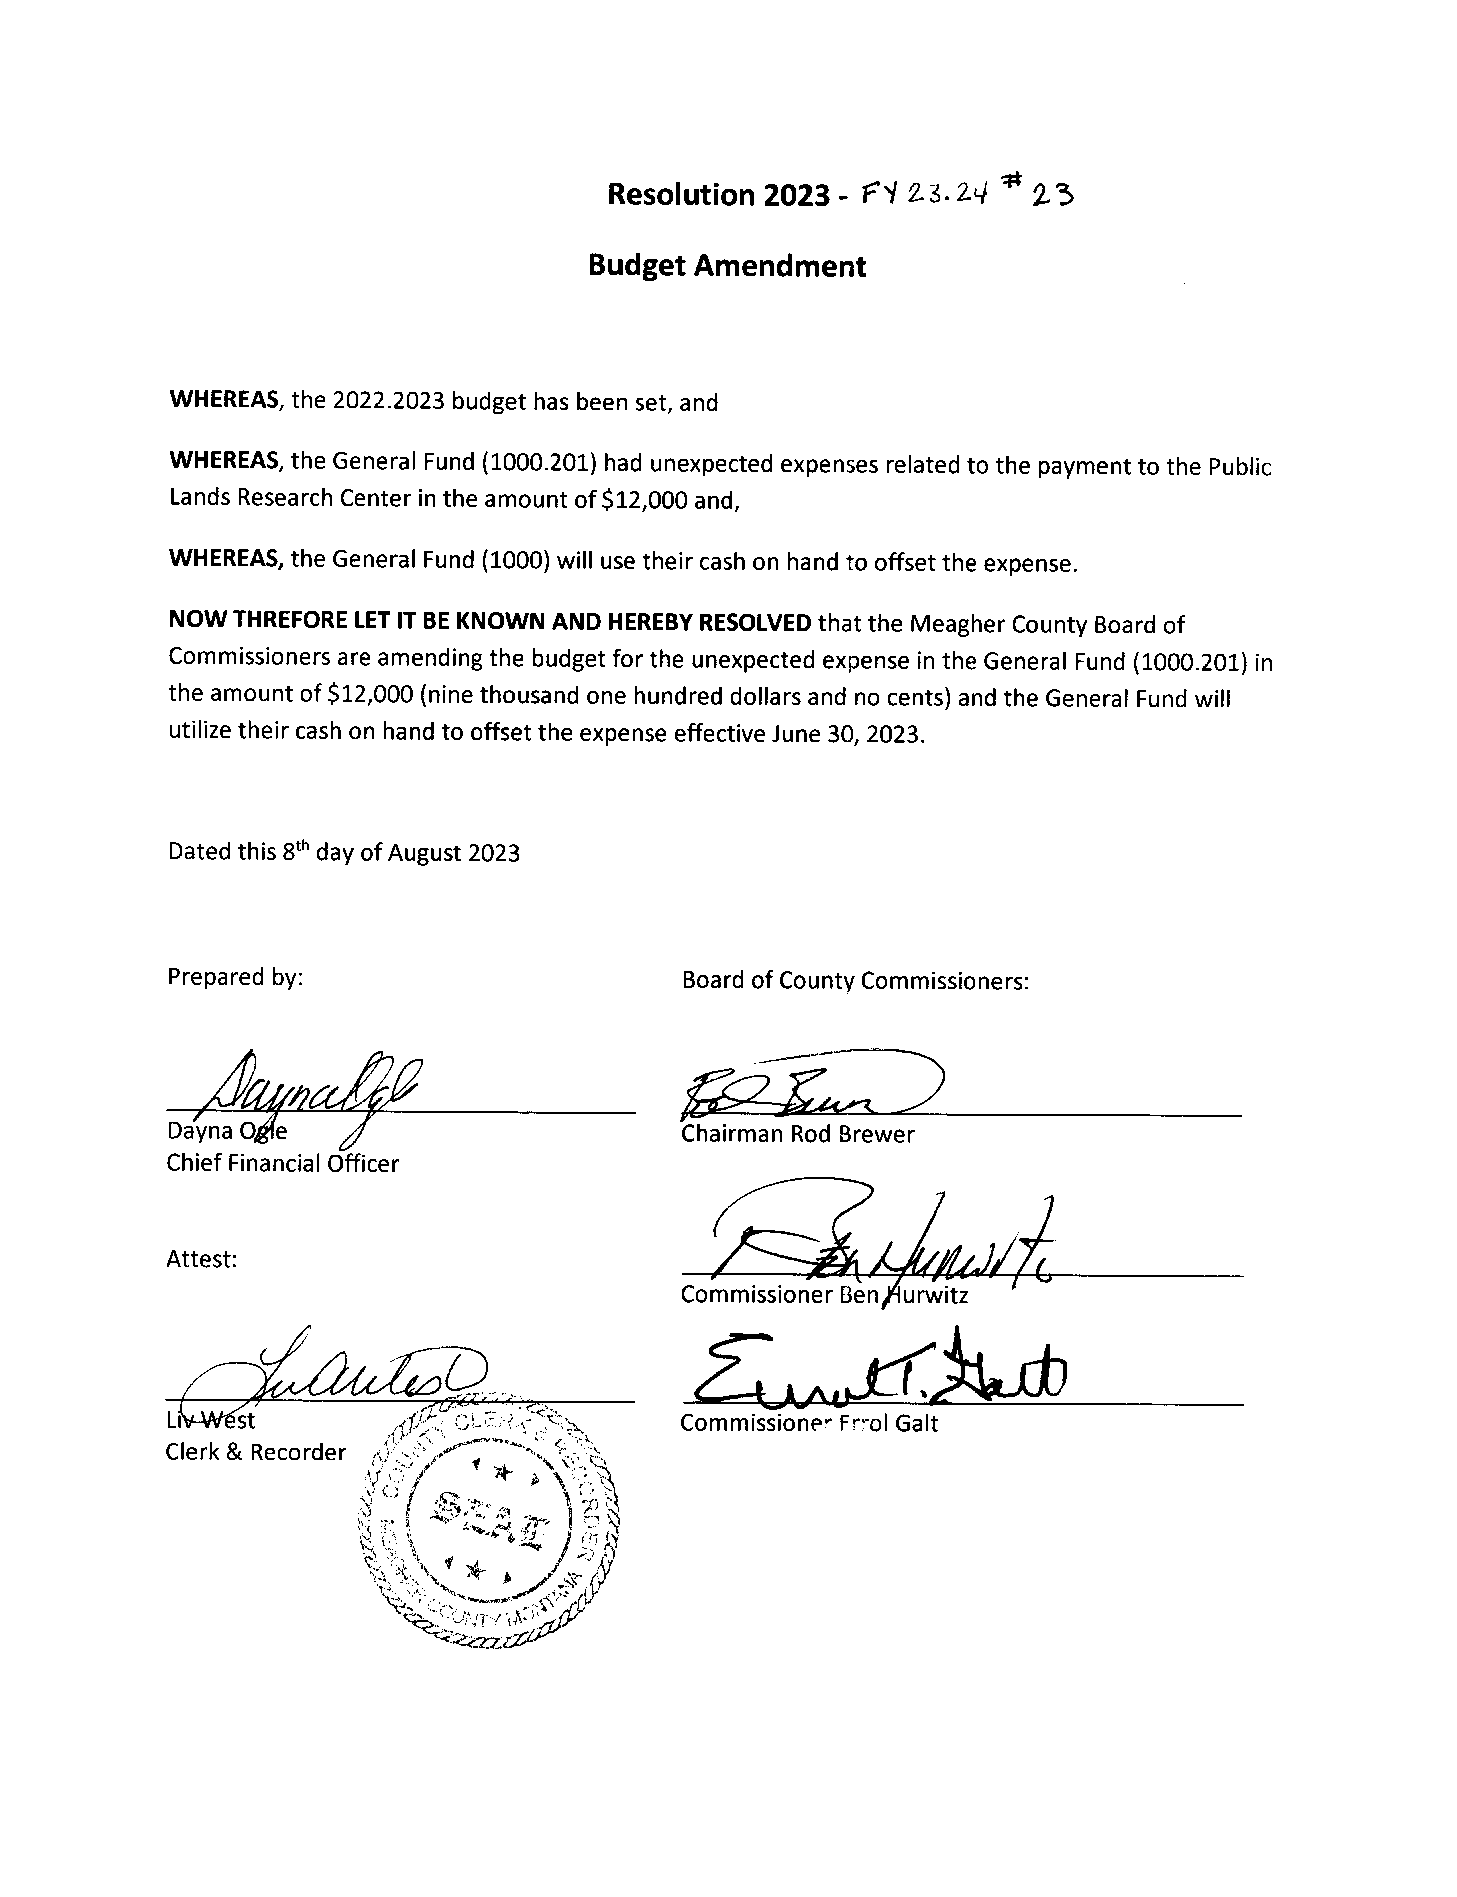

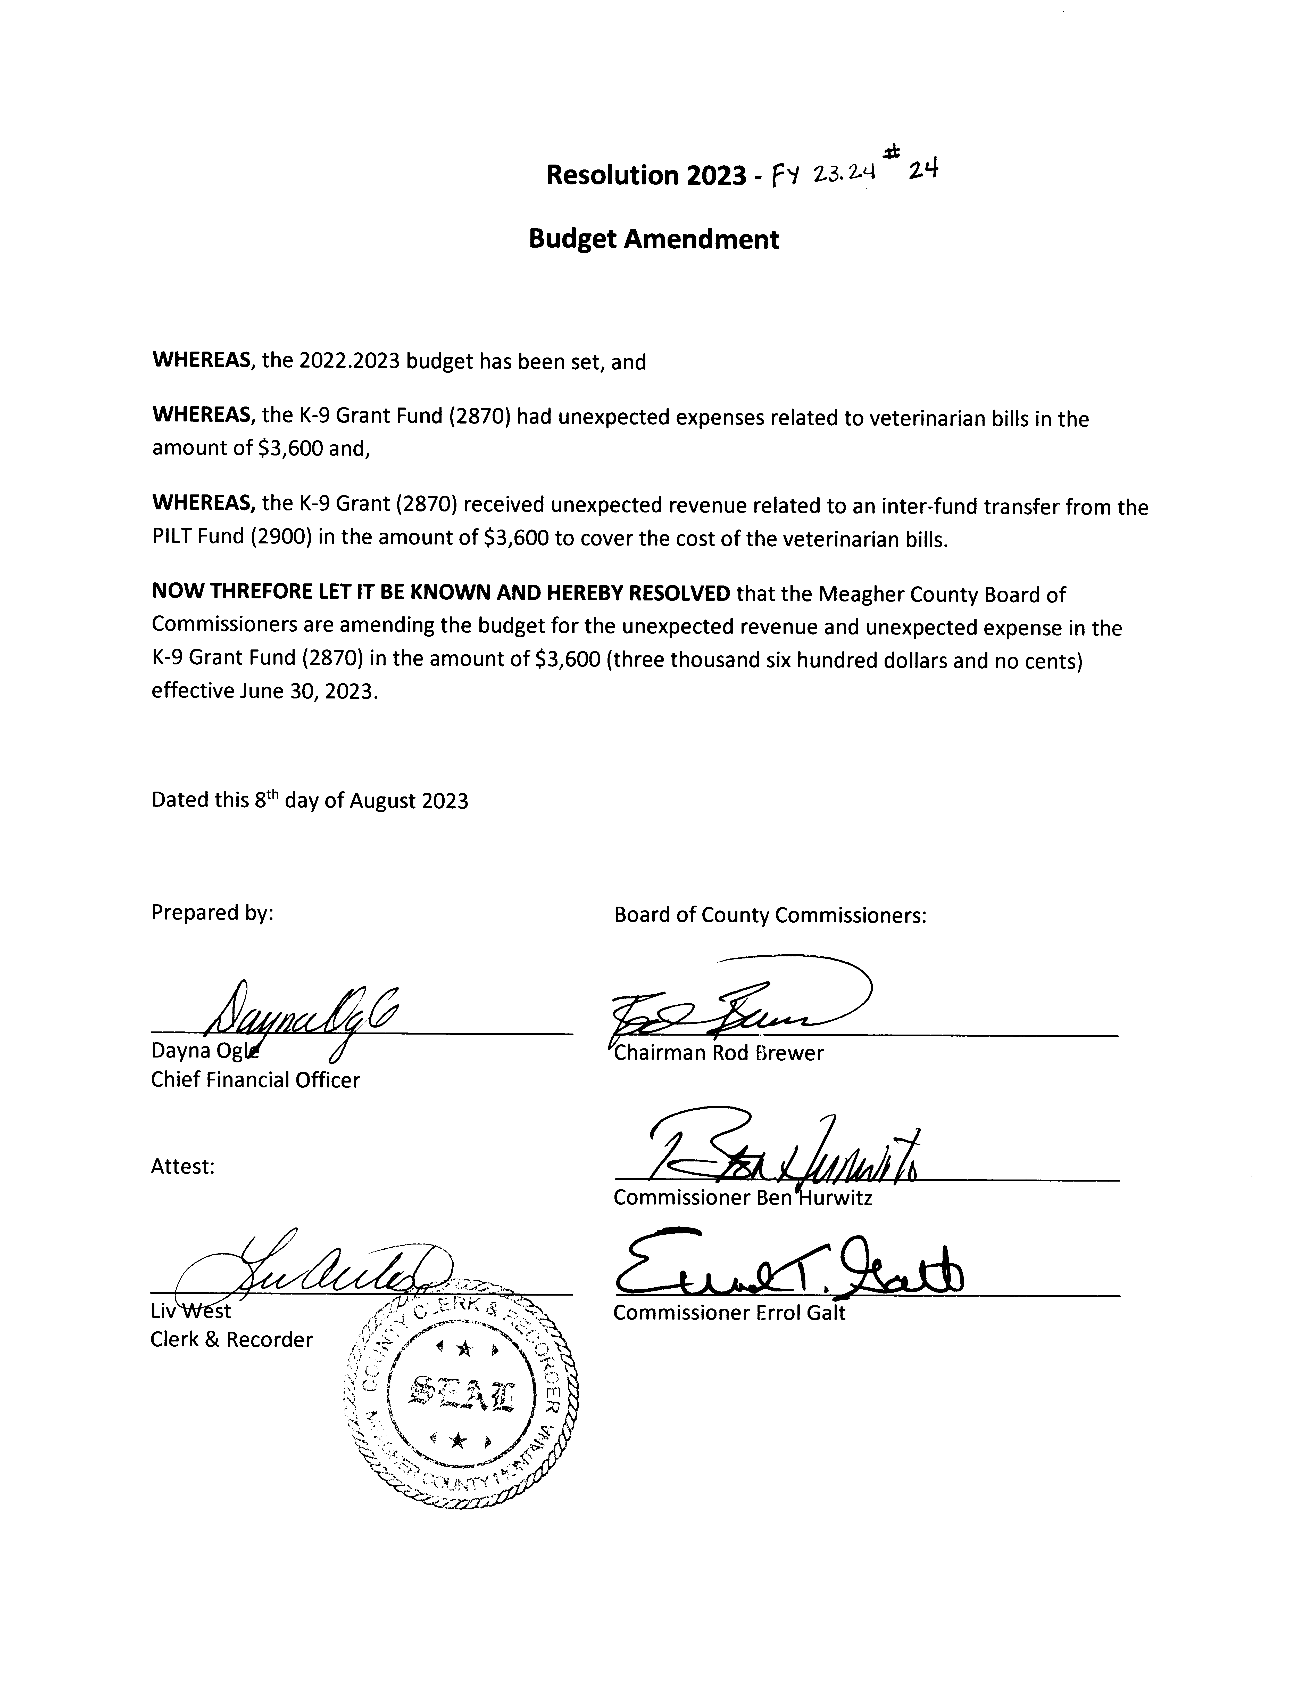
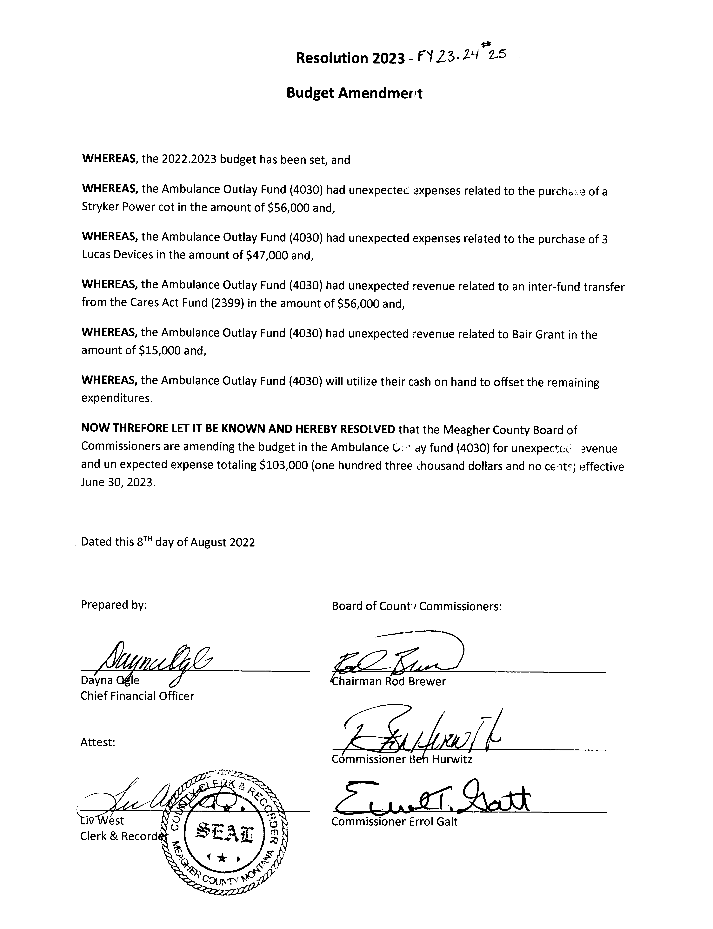

Claims Approved:

Commissioners were presented with Claim Check 60559 through Check 60583 totaling $267,035.19. All Checks were signed as presented.

Meeting Adjourned:

Meeting was adjourned at 1:20 p.m.

Next Meeting:

Commissioners are scheduled to meet Tuesday, August 15th, 2023.

CLERK & RECORDER CHAIRMAN

SEAL VICE-CHAIRMAN

COMMISSIONER

Note: Minutes taken by Chief Financial Officer Dayna Ogle/ formatted by Clerk to the Commission Jennifer Deems.
Distributed August 9th, 2022 to Chairman Brewer, Vice Chair Hurwitz, and Commissioner Galt, and Clerk & Recorder Liv West

